Project Specification Document

------------------------------------------------------------------------------------------------ **Document Version 1.0** **Latest updated: 17-05–2022**

**Author: Suraj Singh Employee Management for Deployment Phase**

***Content***

**About this Document-------------------------------------------------------------------------- 2**

**How this Document is organized------------------------------------------------------------ 2**

**Contact Information--------------------------------------------------------------------------- 3**

**Introduction------------------------------------------------------------------------------------- 4**

**Objectives---------------------------------------------------------------------------------------- 4**

**Flow chart diagram---------------------------------------------------------------------------- 5**

**Application Architecture--------------------------------------------------------------------- 6**

**Technologies Used in this Application----------------------------------------------------- 7**

**Solution Overview for Application Deployment on AWS Cloud -------------------- 8 to 39**

**Solution Overview for Application Employee Management and its working ---- 40 to 54**

**DataBase Details------------------------------------------------------------------------------ 55 to 56**

**Application Link After Deployment on AWS Cloud---------------------------------- 57**

**GitHub link------------------------------------------------------------------------------------- 57**

**About this Document**

This functional and integration (FIS) document will enable you to understand the proposed solution of EmployeeManagement.com || The content of the document will have a solution and its configuration details as it will be available for our client.

**How this Document is organized**

* This document is organized into following chapters:
* "Introduction" provides solution scope to be delivered to our client.
* "Flow chart" provides how the user is interacting with the application.
* "Solution Overview" provides Deployment Information and information on Employee Management Pvt. Ltd., Components and Interfaces in system.
* **DataBase Details** provides the information about Database.
* **“Link of Project after Deployment of Project”** provides the information about link of Project.
* **“GitHub link”** provides the information where the project is located.

**Contact Information**

Employee Management App invites your comments and suggestions on the quality and usefulness of this document. For any questions, comments, or suggestions on the documentation, you can contact us at the following address:

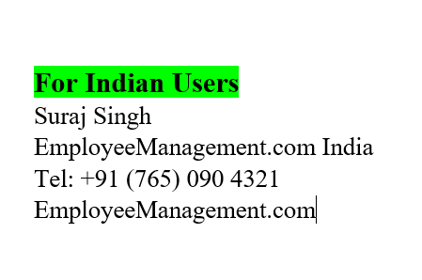

**Introduction**

This document describes the implementation of *Employee Management* and how its users can interact with the application.

*Employee Management is a portal that has capability to manage data of Employee for any organization.*

**Objectives**

*The Employee Management system creates an application that enables users to manage data for employee for any organization.*

This system contains four main modules: ADD, UPDATE, DELETE and VIEW.

ADD section of the *Employee Management* Provides facility for adding data of Employee.

UPDATE section of the *Employee Management* Provides facility for Updating data of Employee.

DELETE section of the *Employee Management* Provides facility for deleting data of Employee.

VIEW section of the *Employee Management* Provides facility for Viewing data of Employee.

***Flow Chart Diagram***

**Browser**

**DB**

**Employee Repository**

**Employee Service**

**Employee Controller**

**Employee List View**

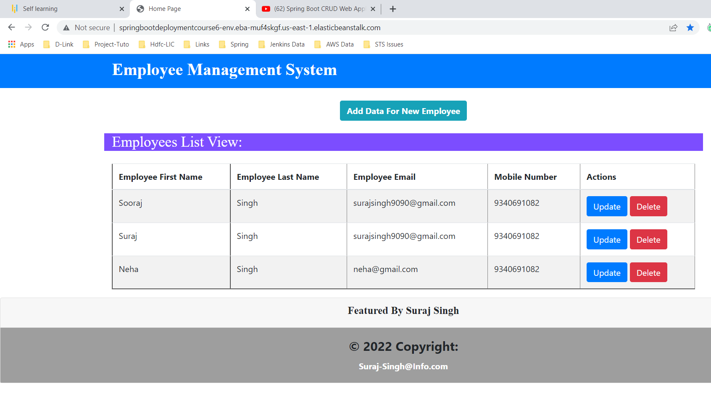

**Application Architecture**

**DB**

**Thymeleaf**

**Employee Controller**

**Employee Service**

**Employee Repository**

**Front End Part BackEnd DataBase**

**Technologies Used in this Application**

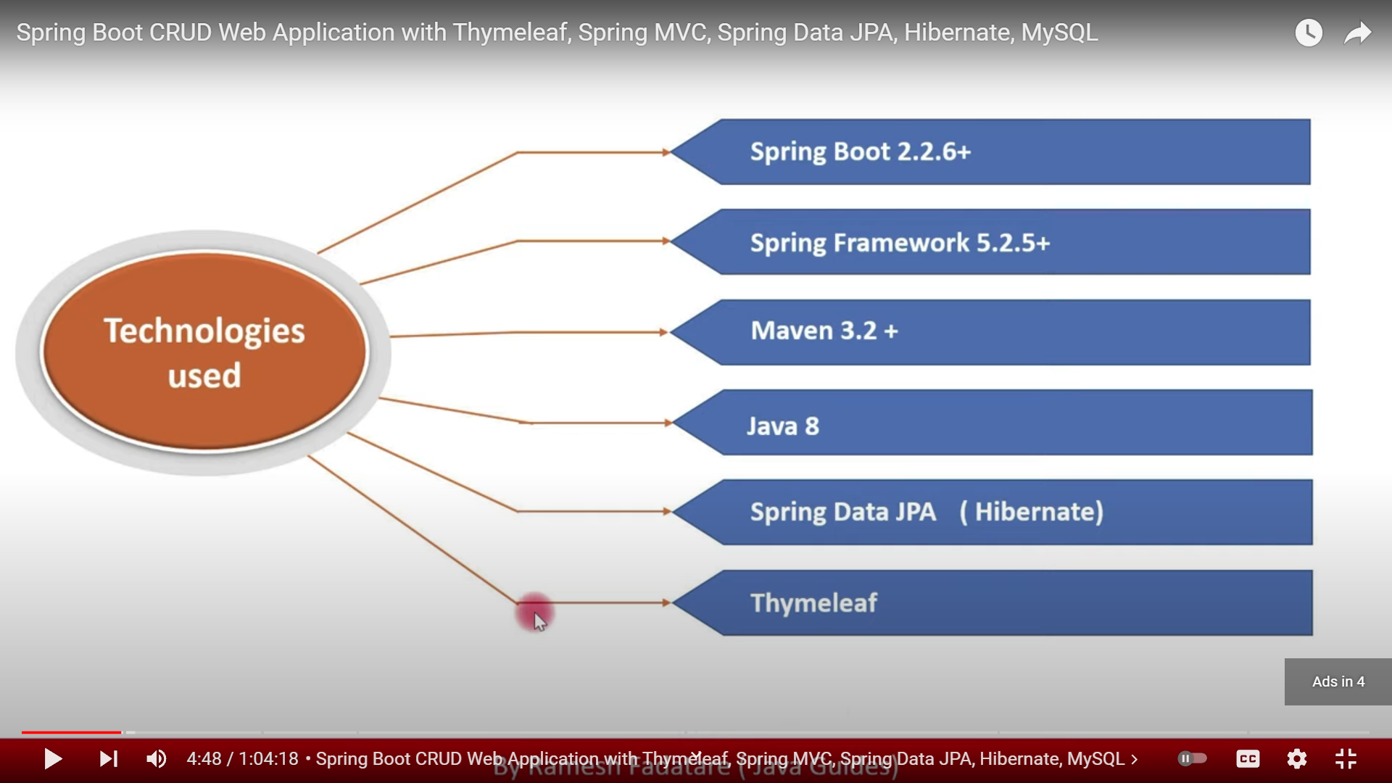

**Solution Overview**

**Platform requirement**

The platform used for this project is the STS IDE, MySQL Workbench, MAVEN, AWS.

**"Solution Overview" For Application Deployment on AWS Cloud**

It contains information about that How to create DataBase Enjoinment on AWS and How to Deploy Application on AWS after creating JAR File of Application.

**Creation of DataBase Enviorment on AWS**

DB Intances Name- employee-management

Username - root

Password – root1234

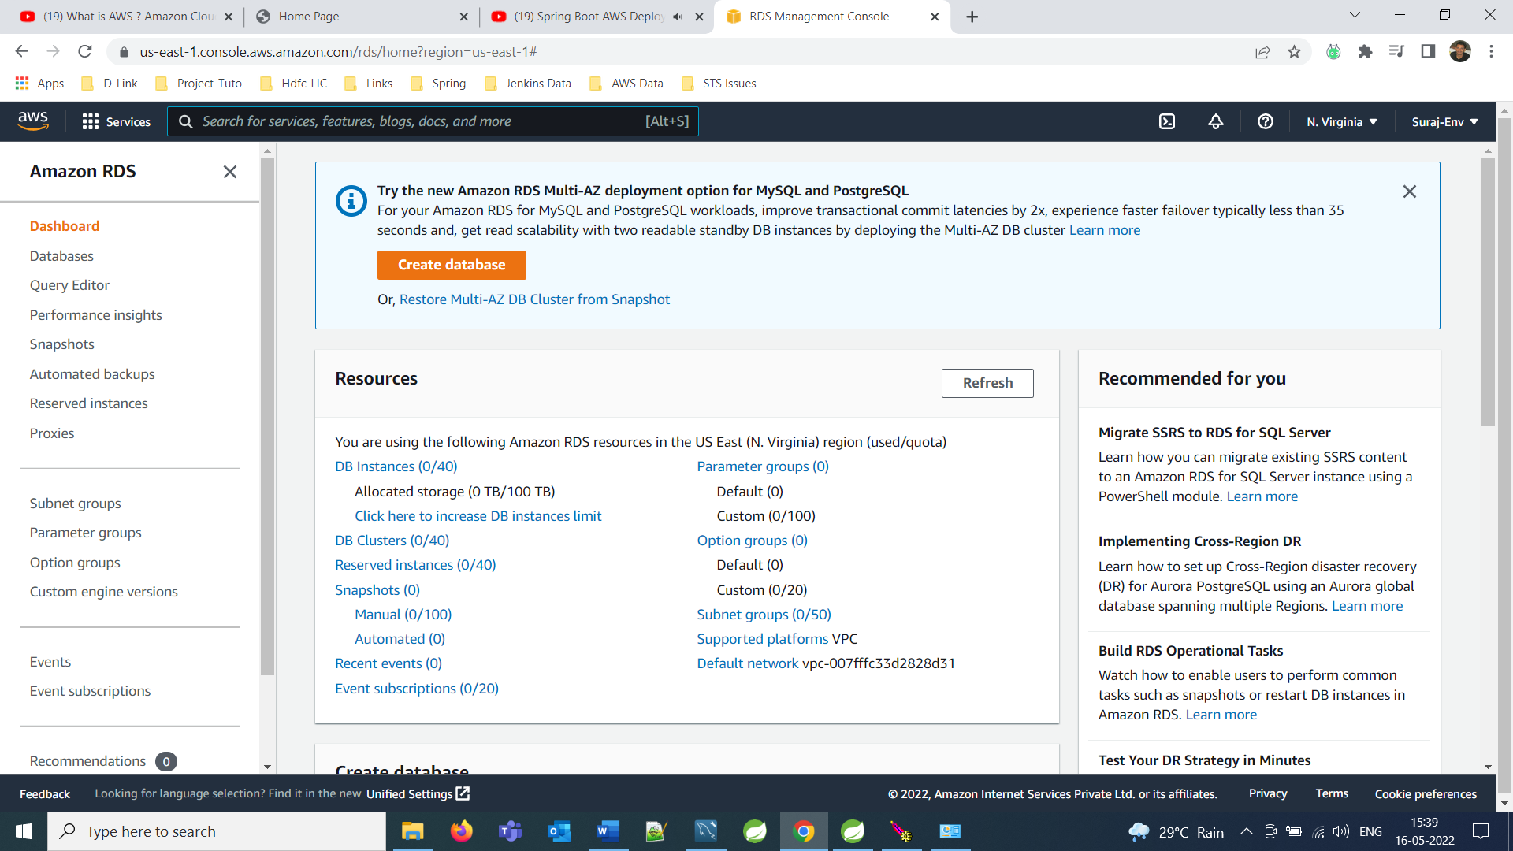

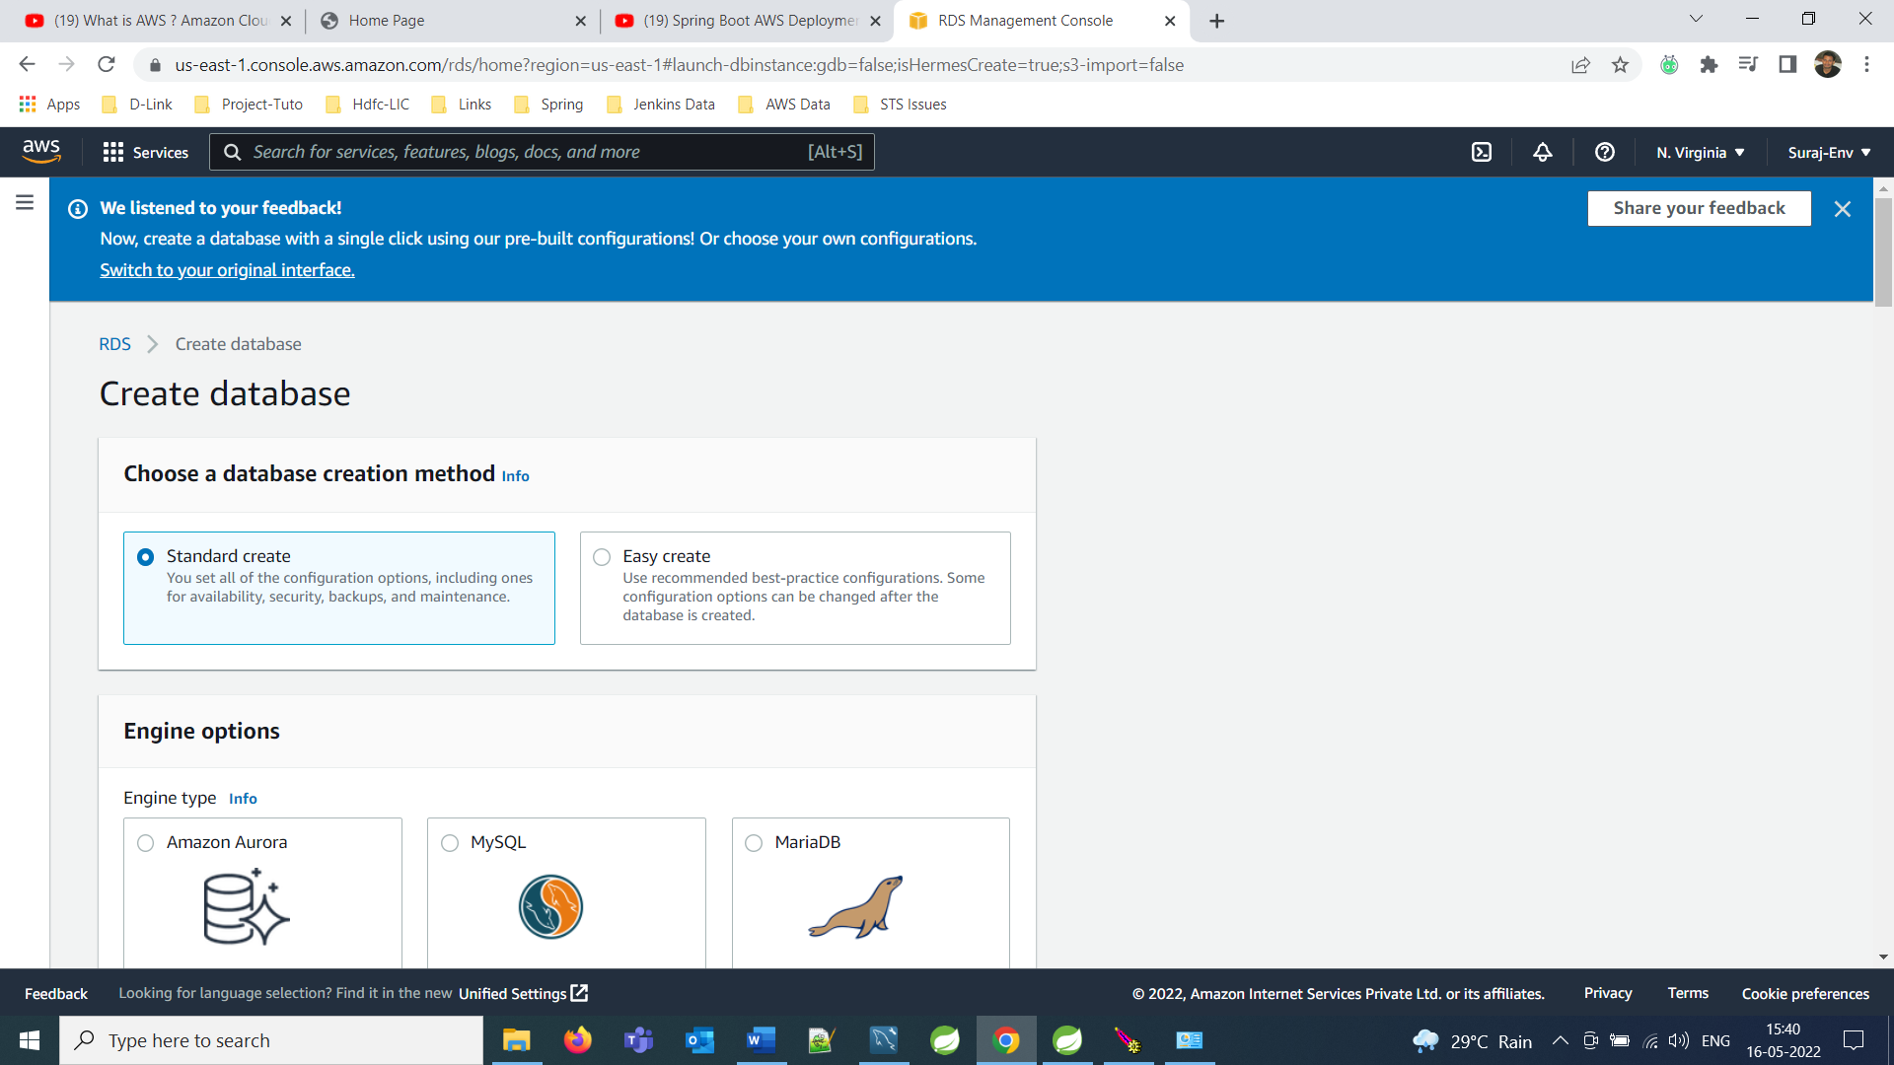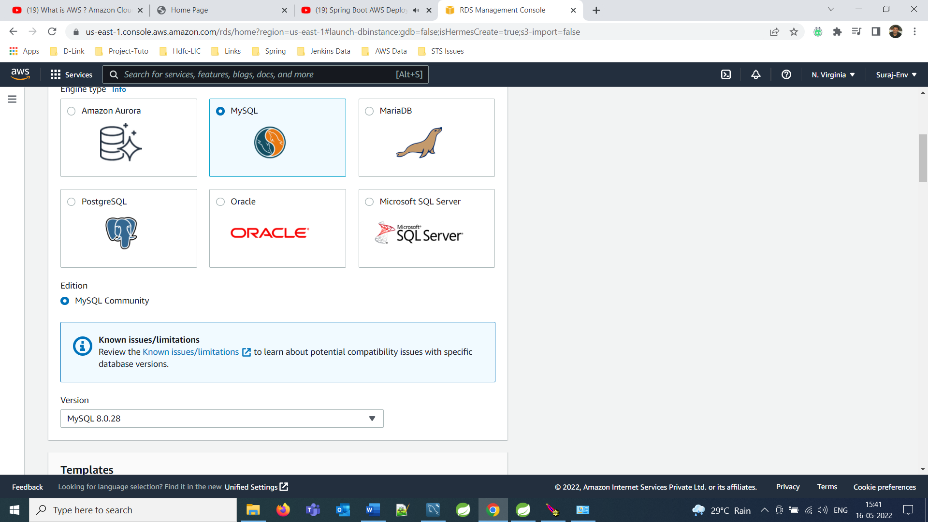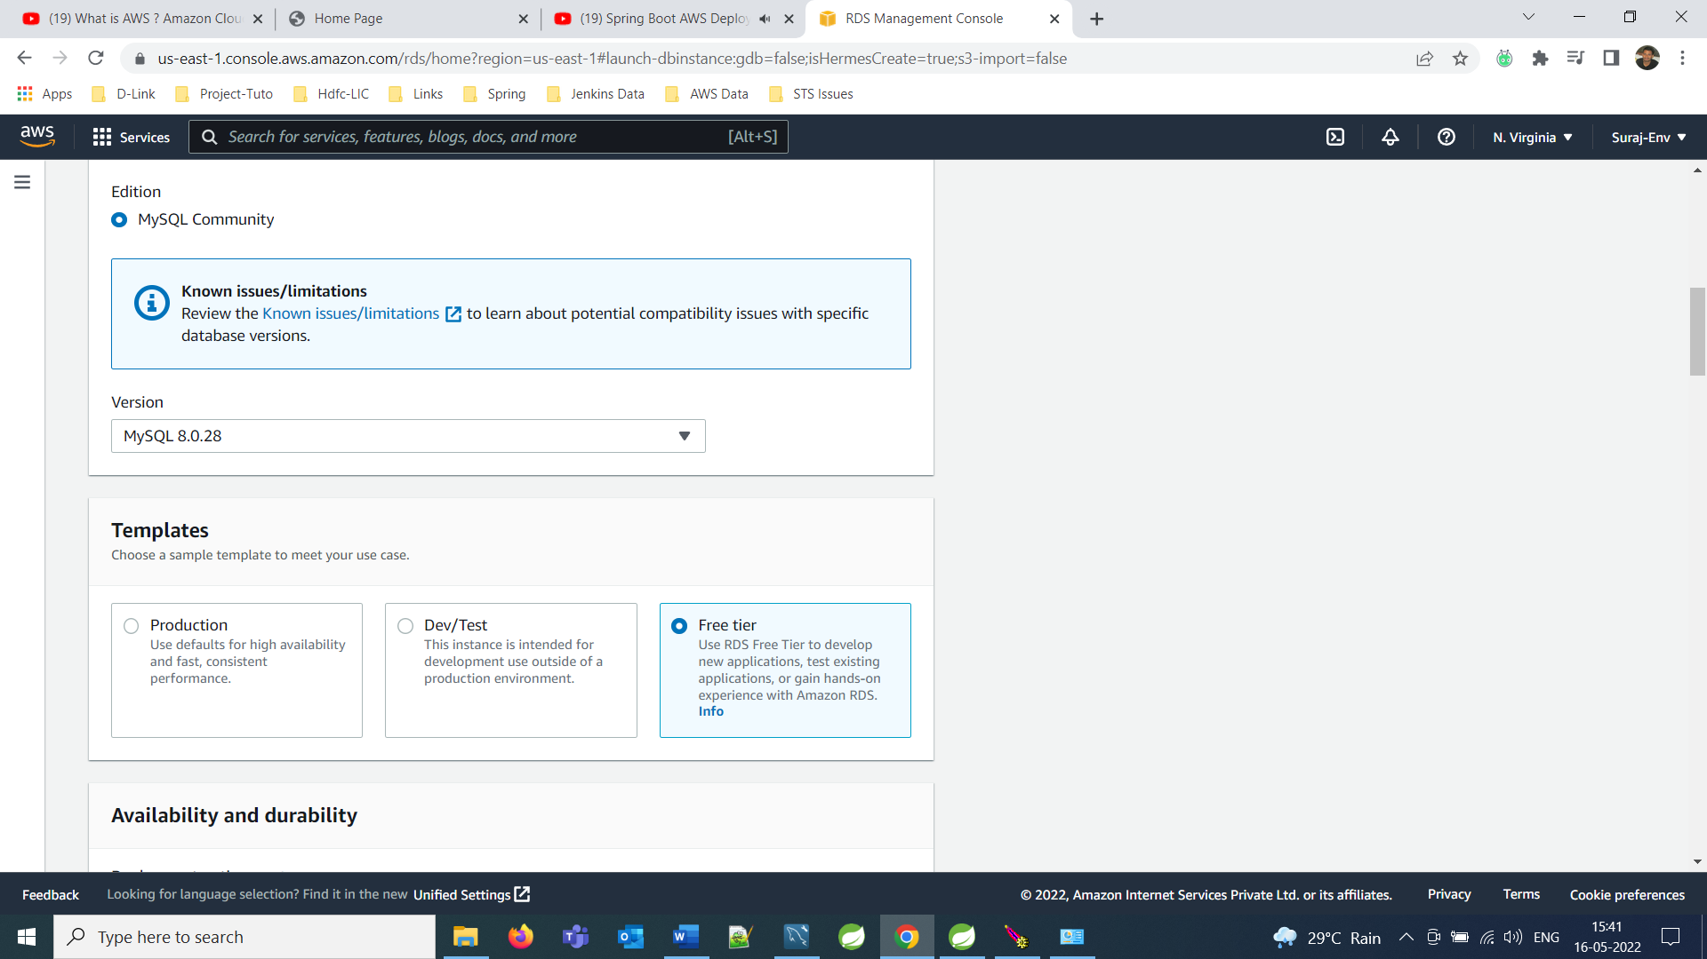

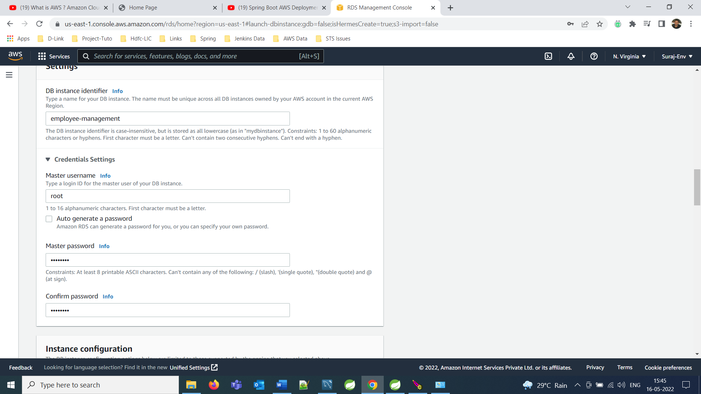

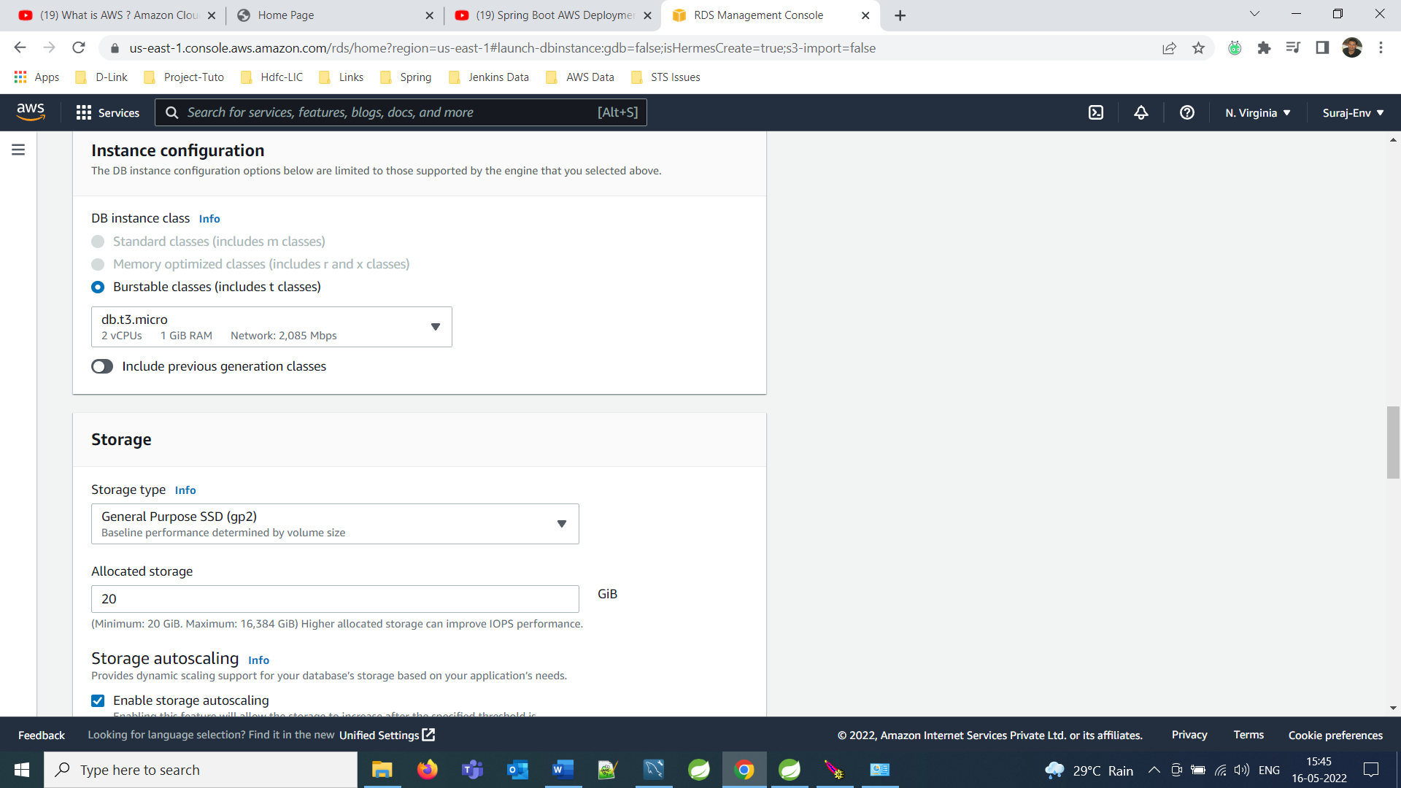

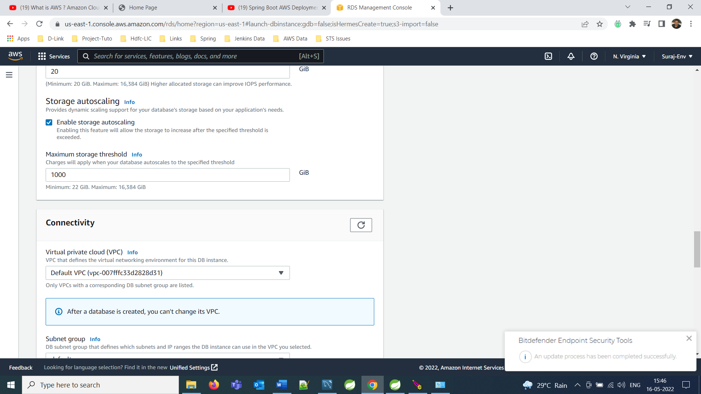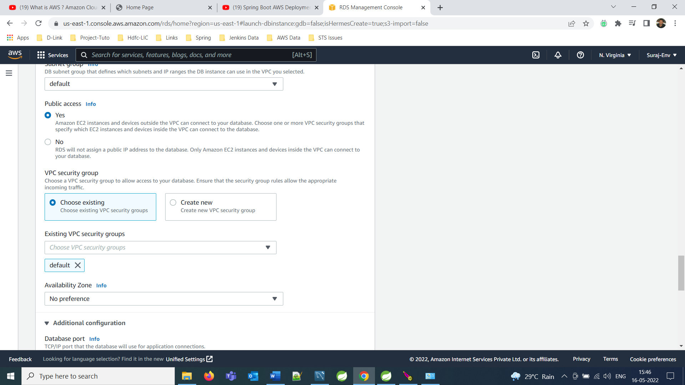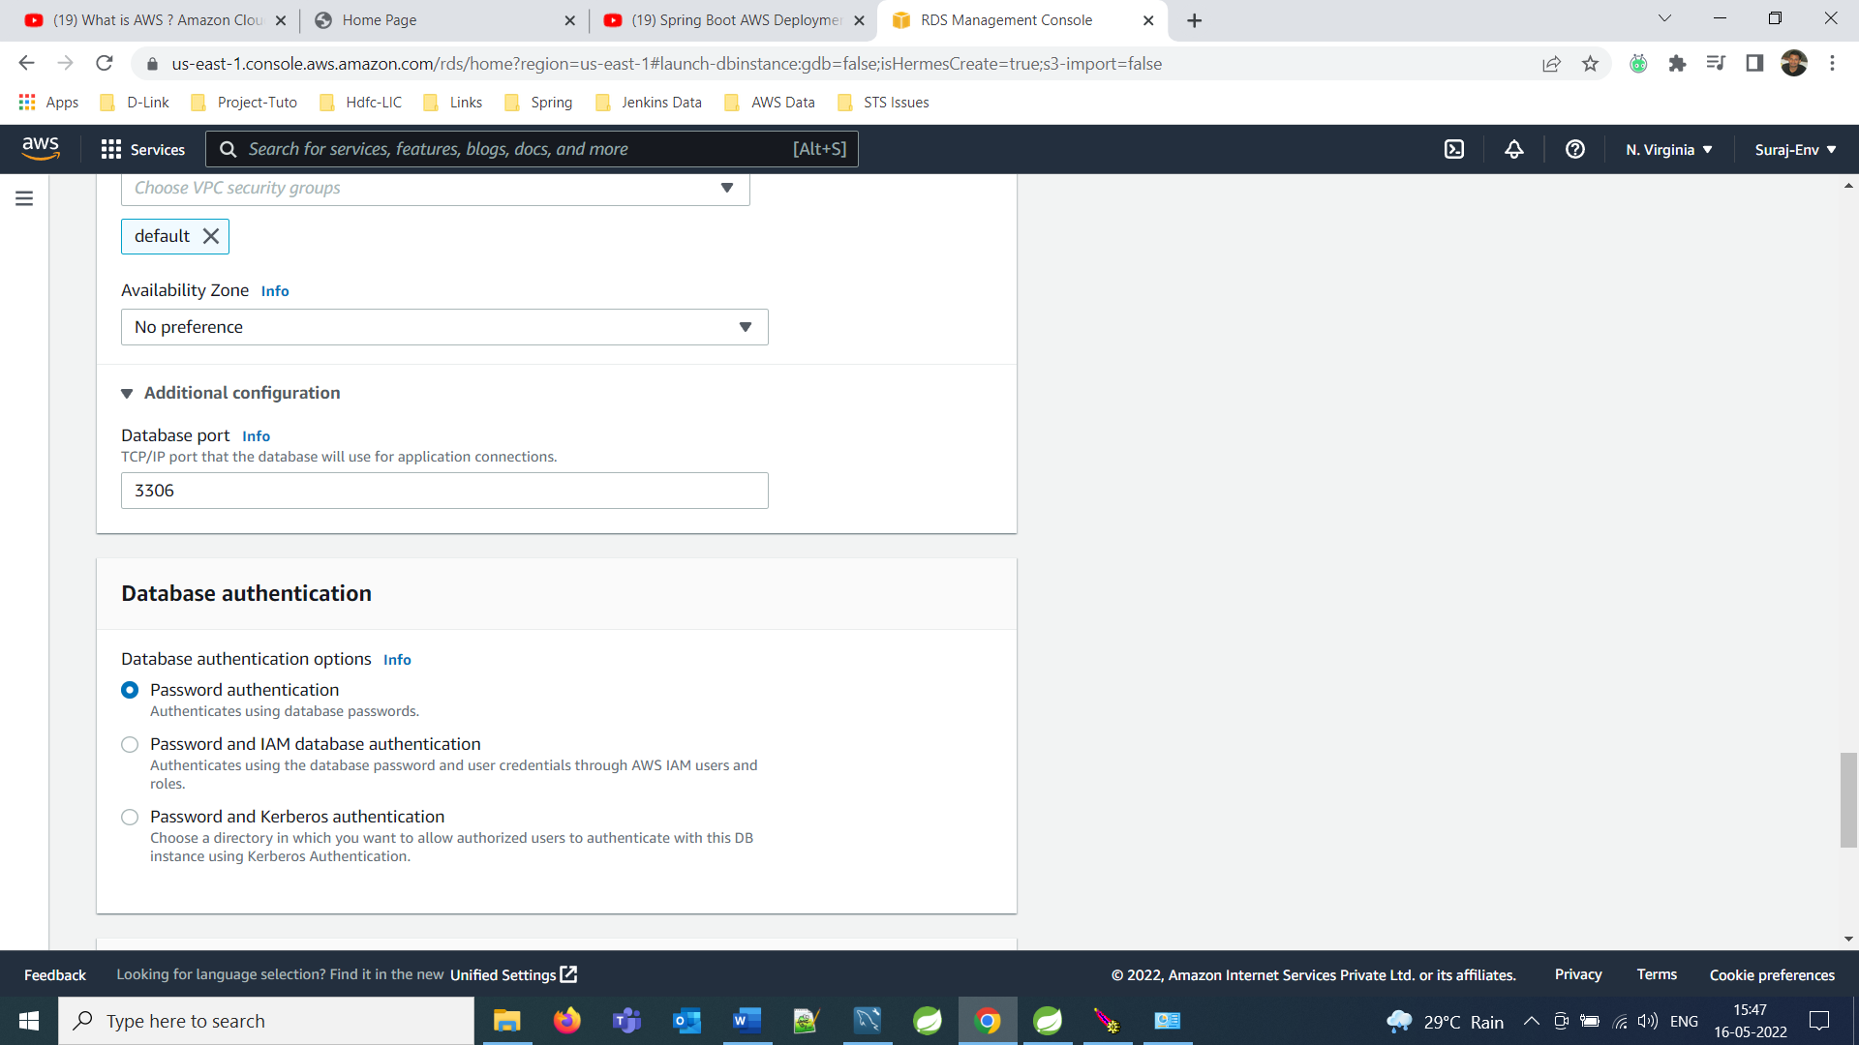

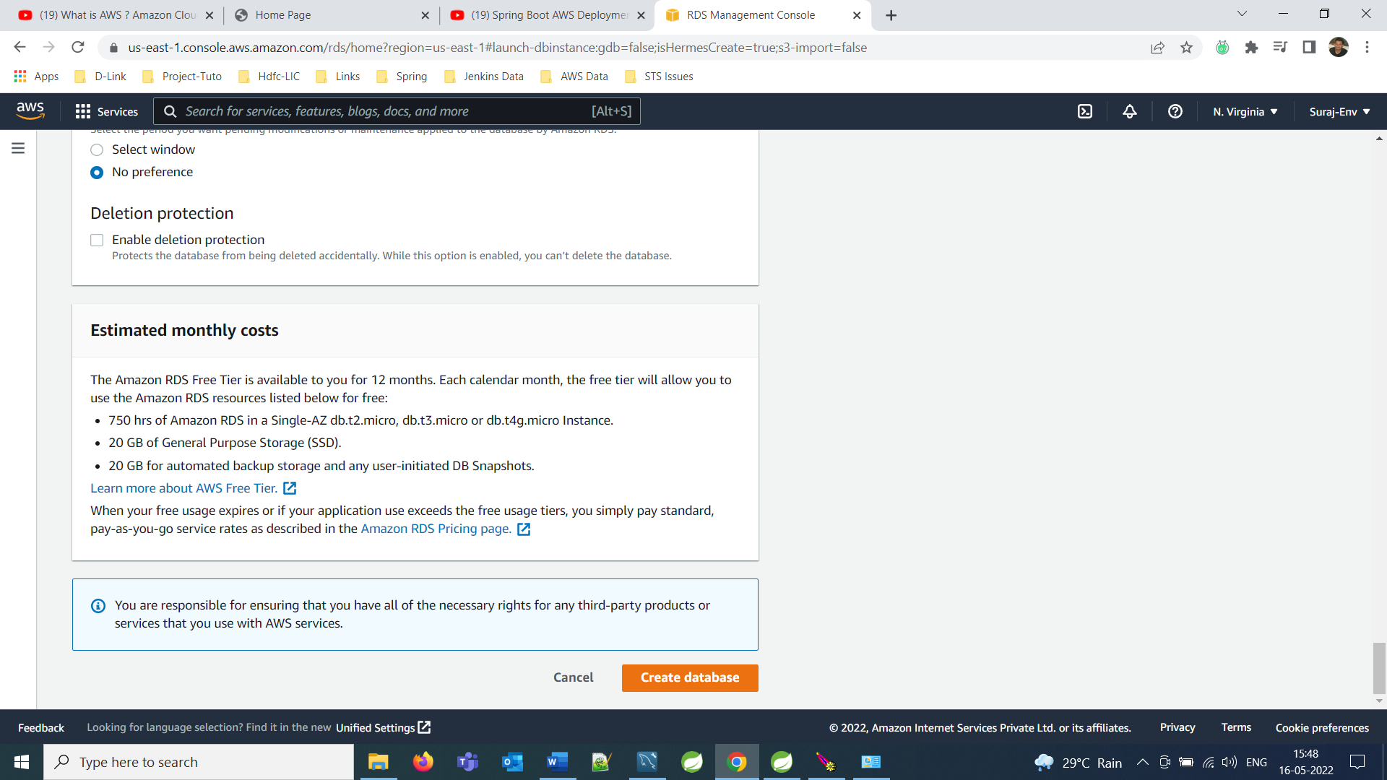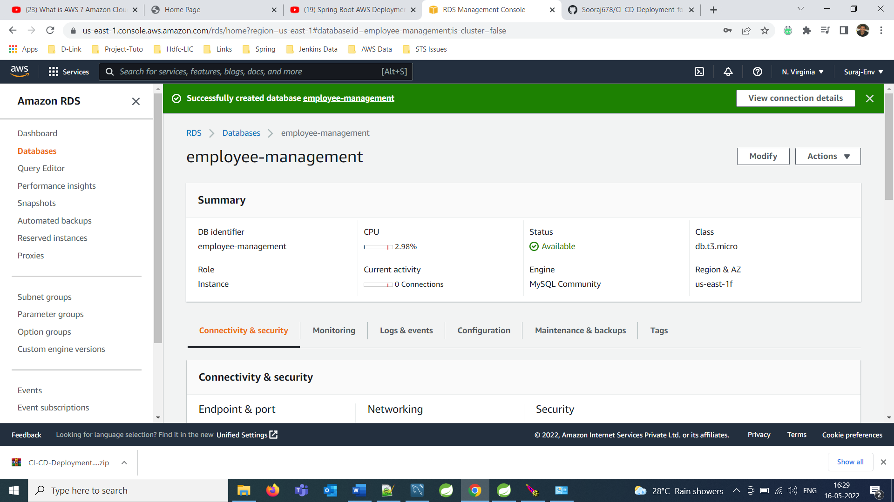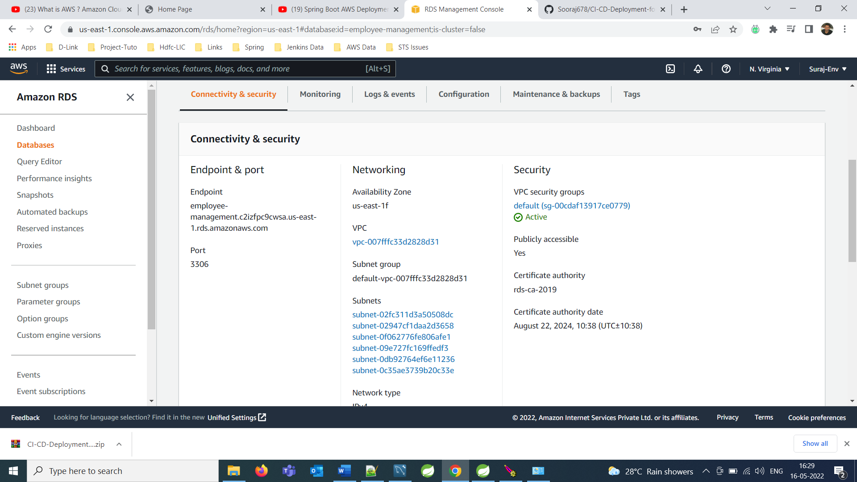

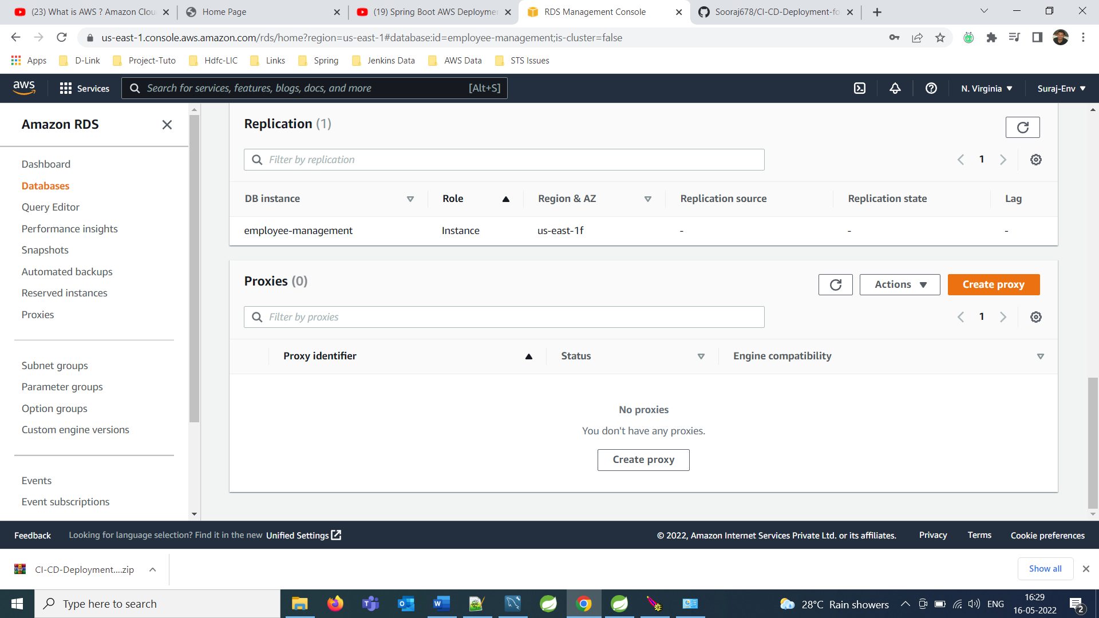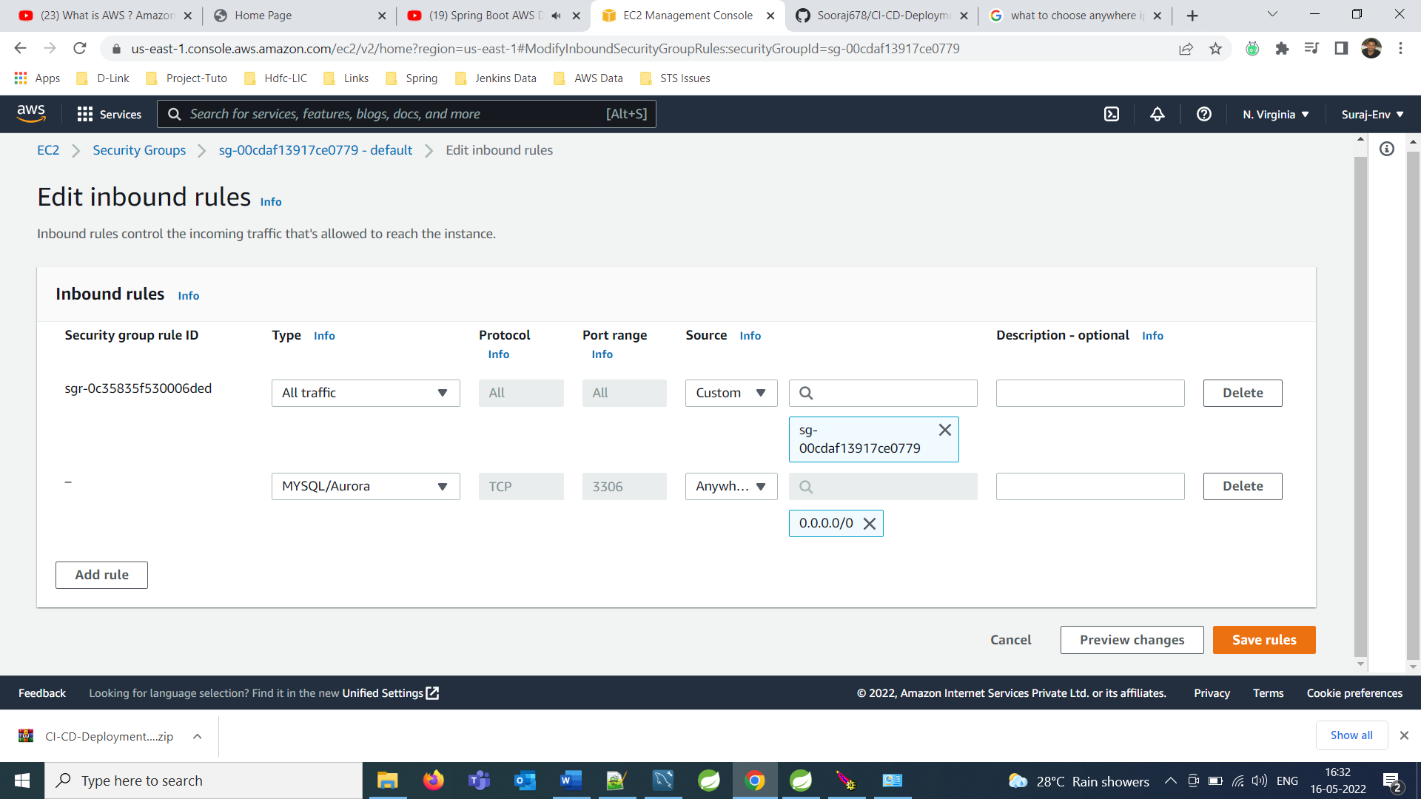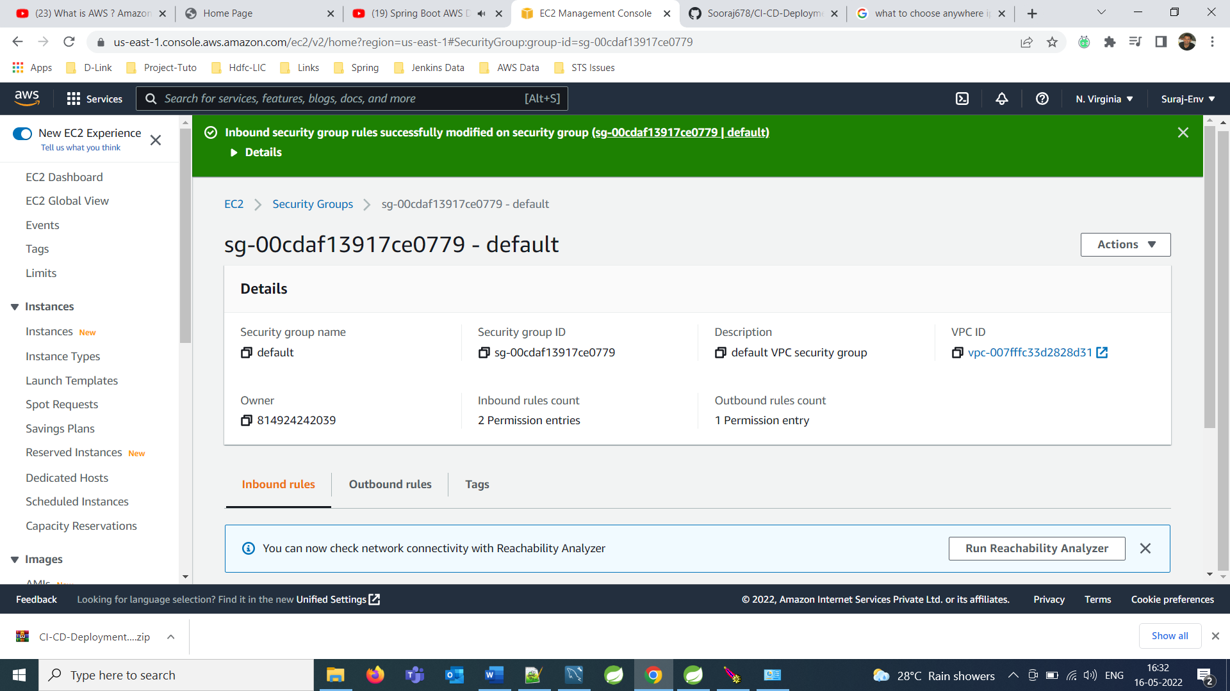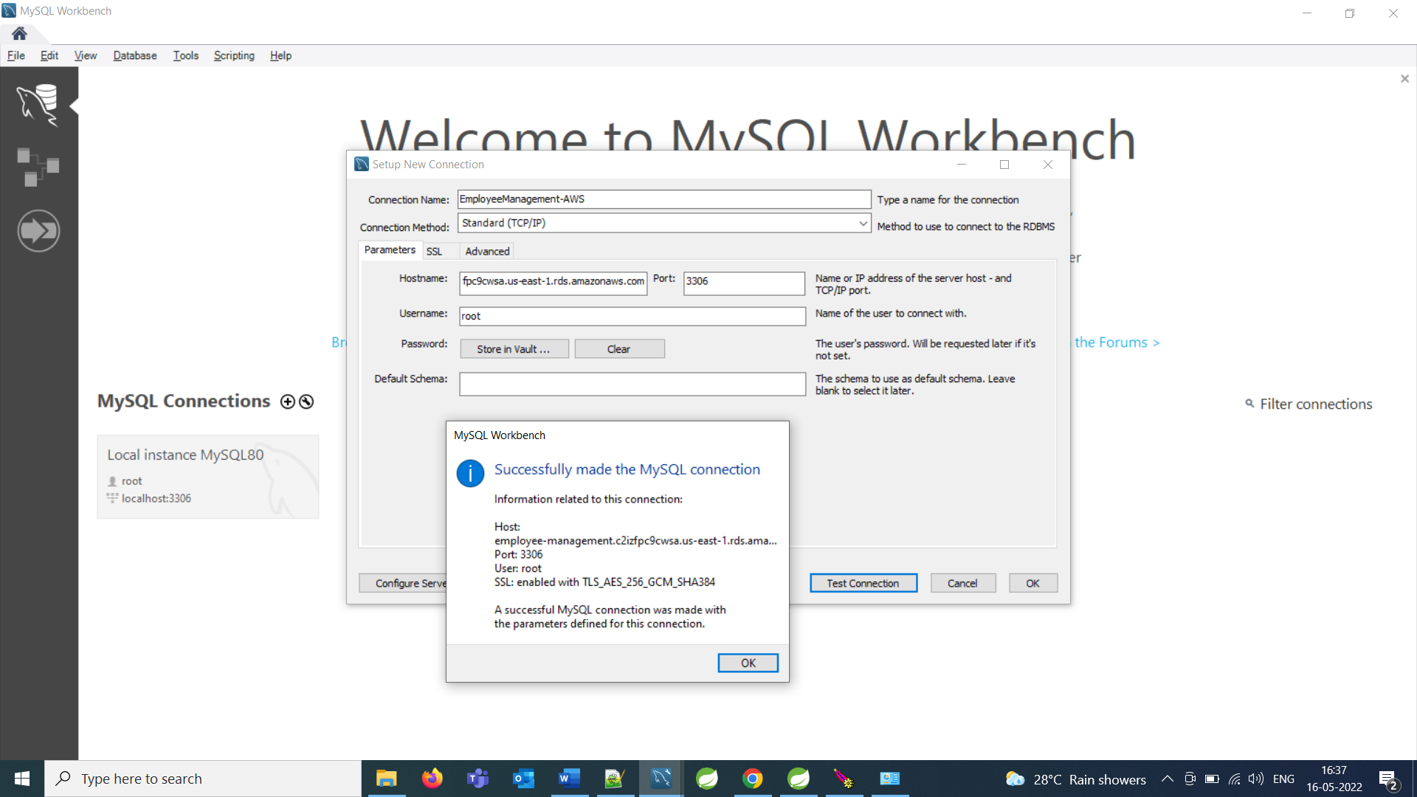

***Deployment of Application on AWS***

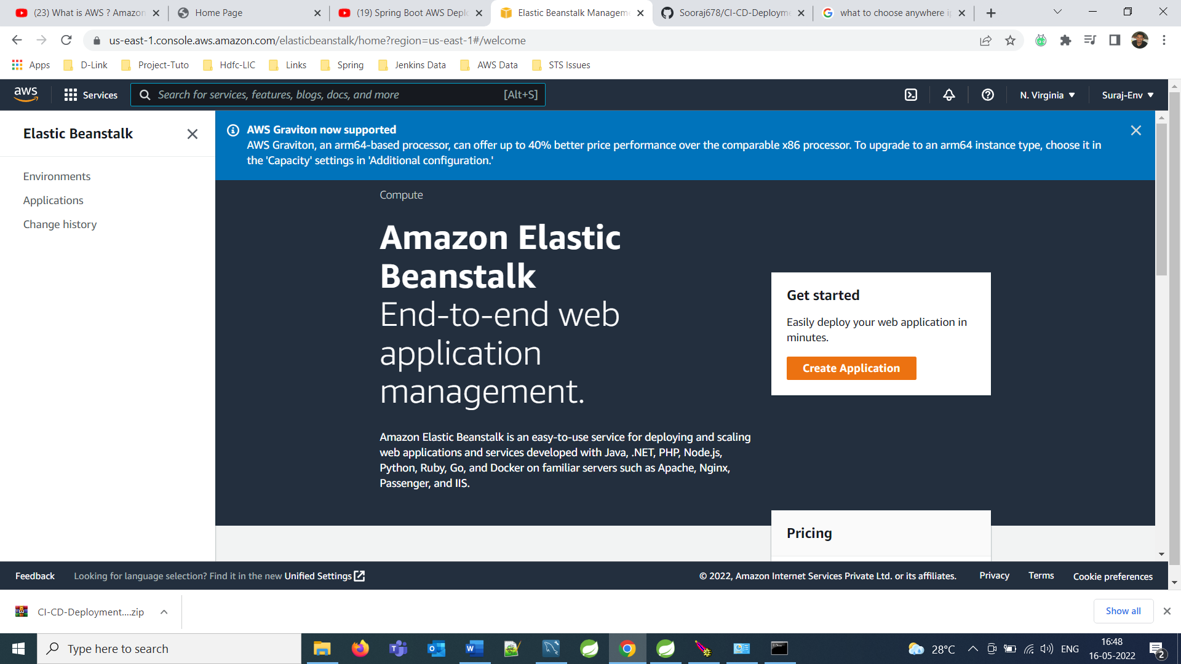

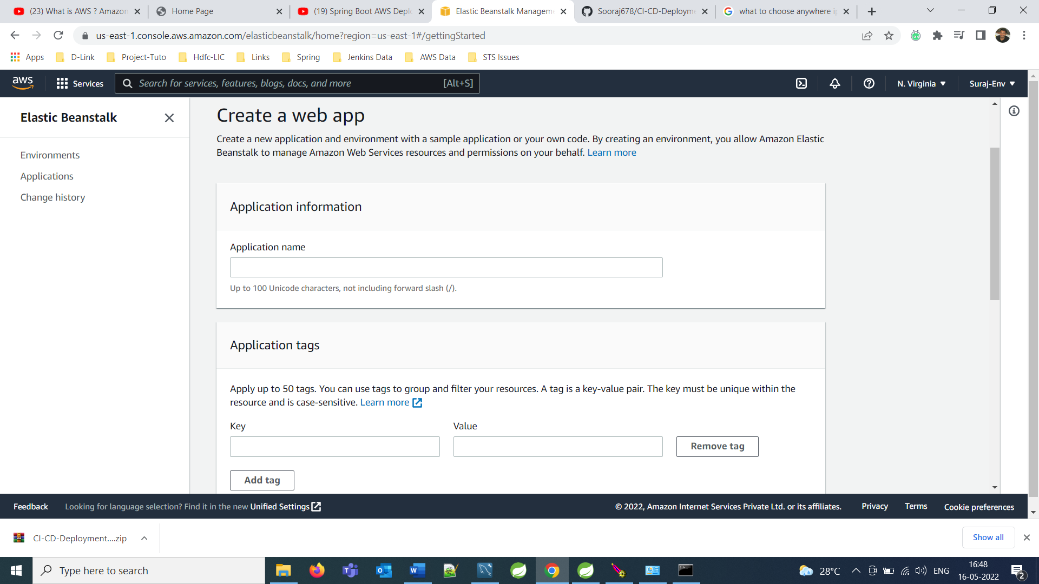

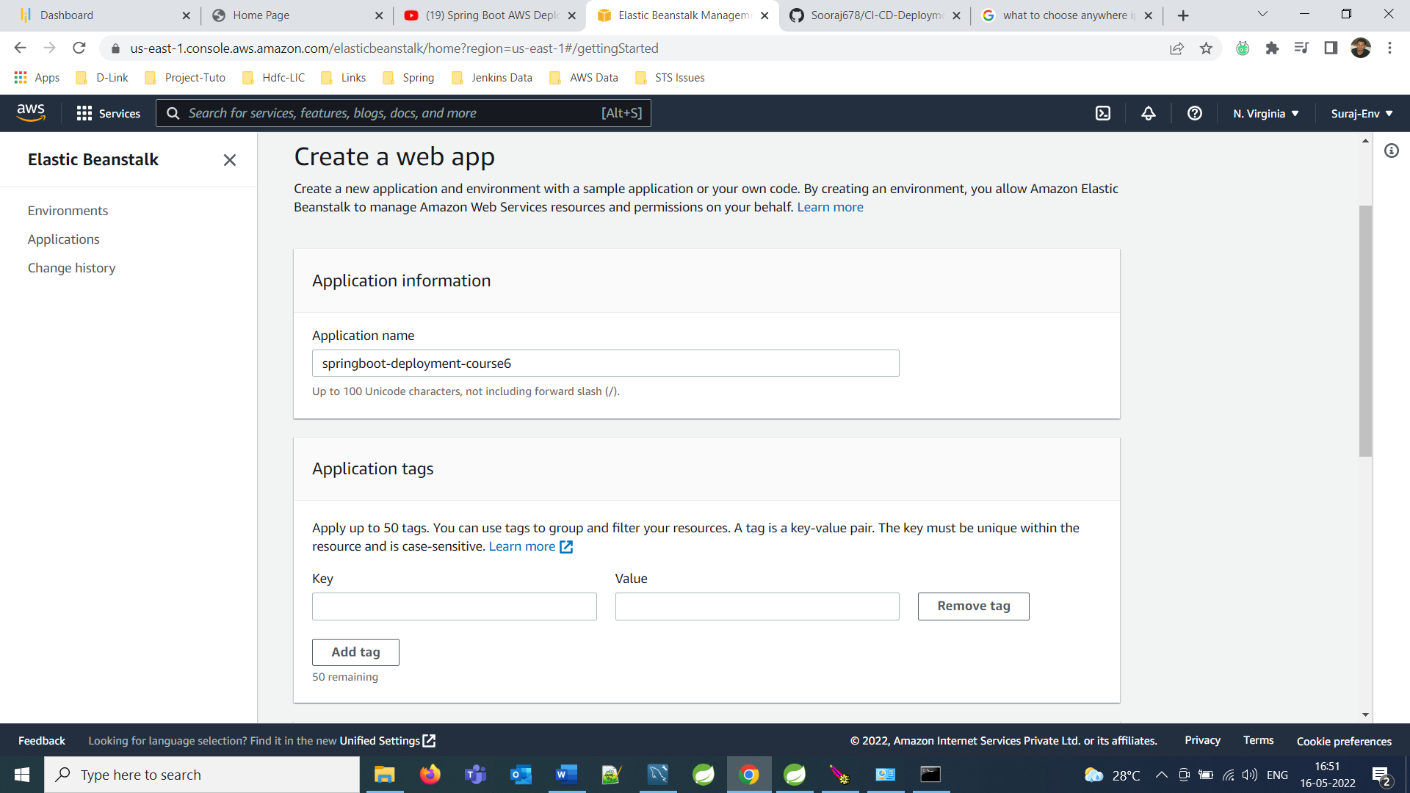

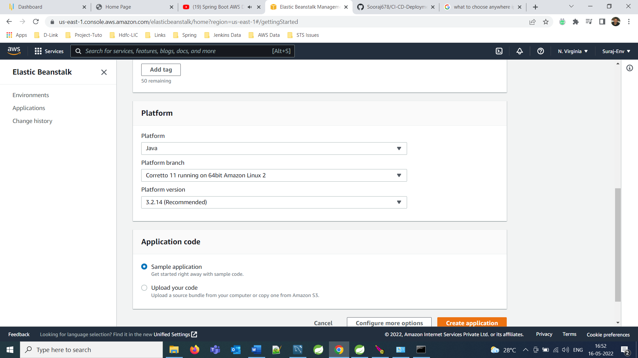

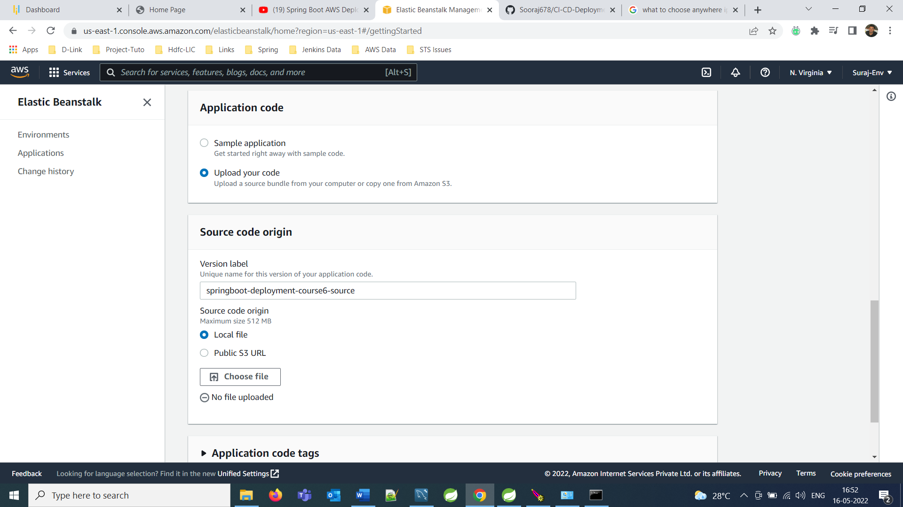

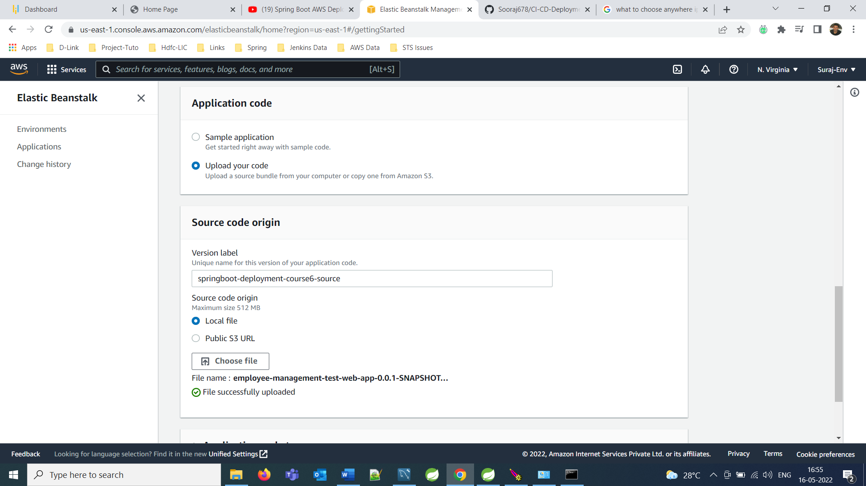

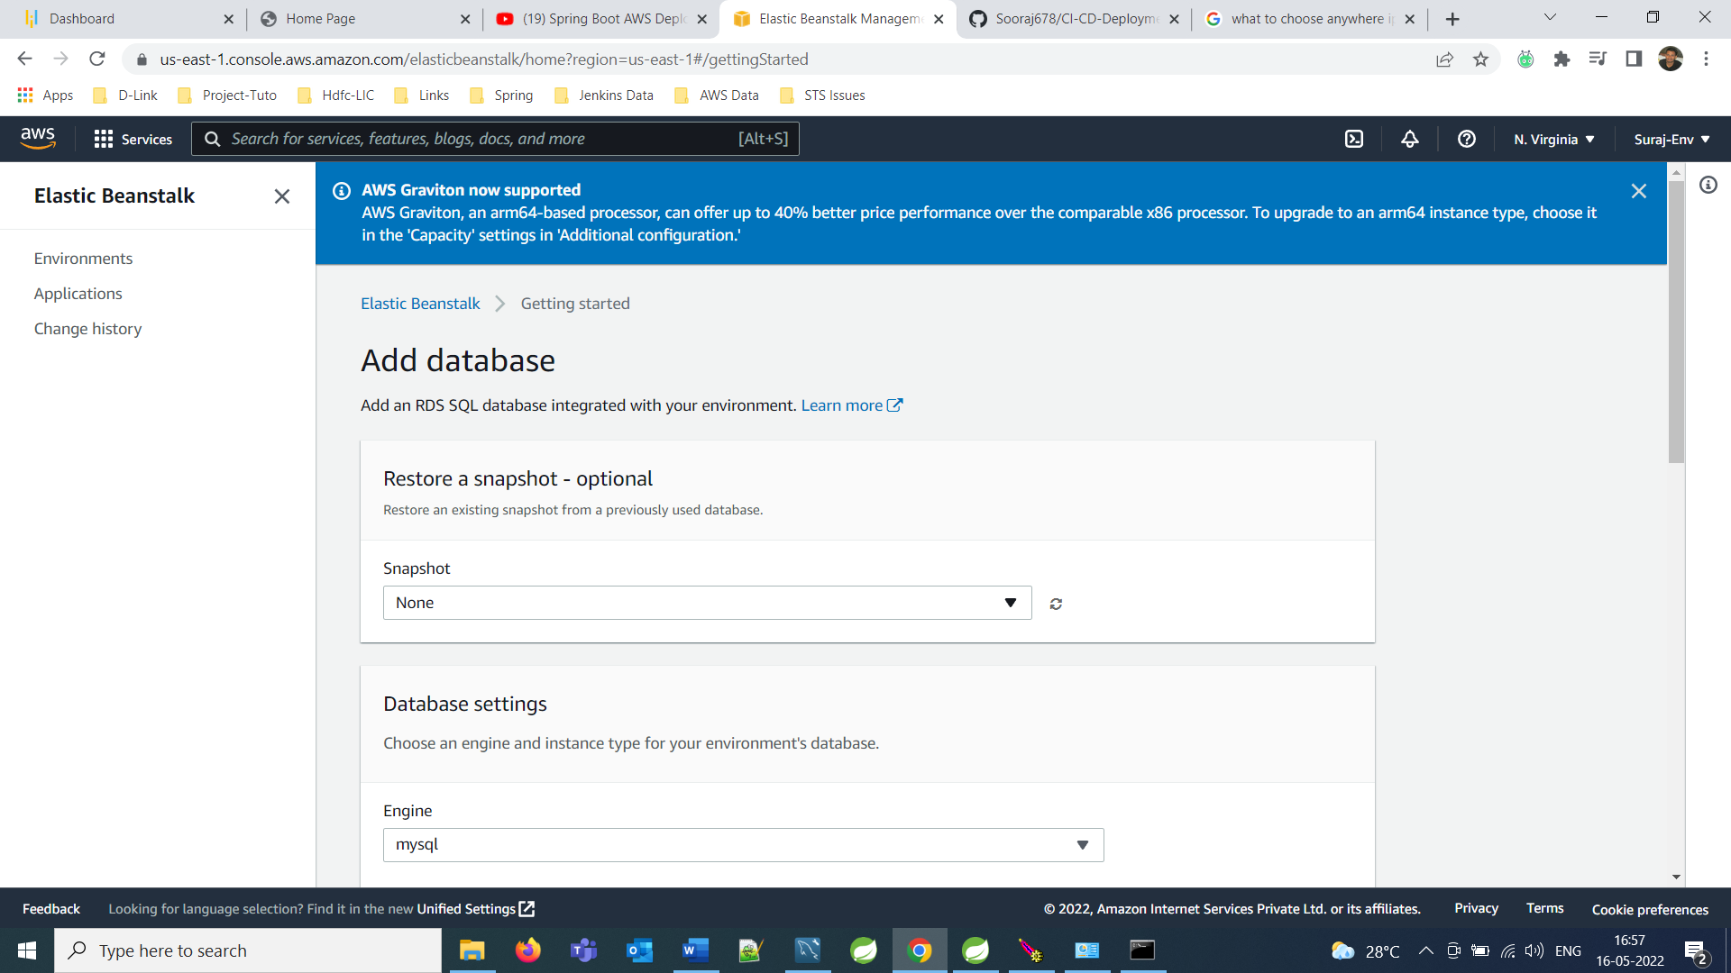

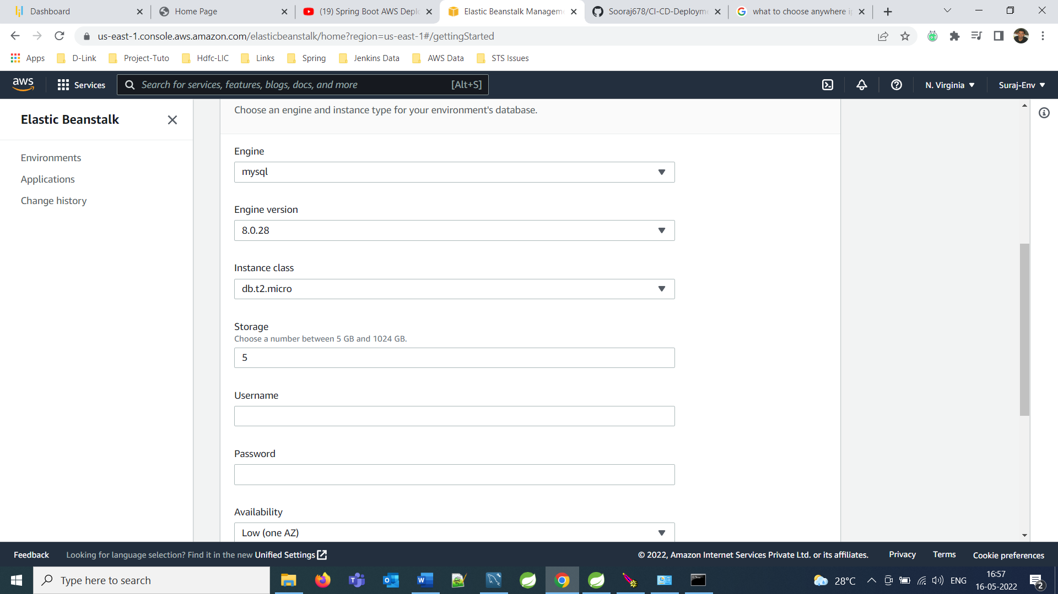

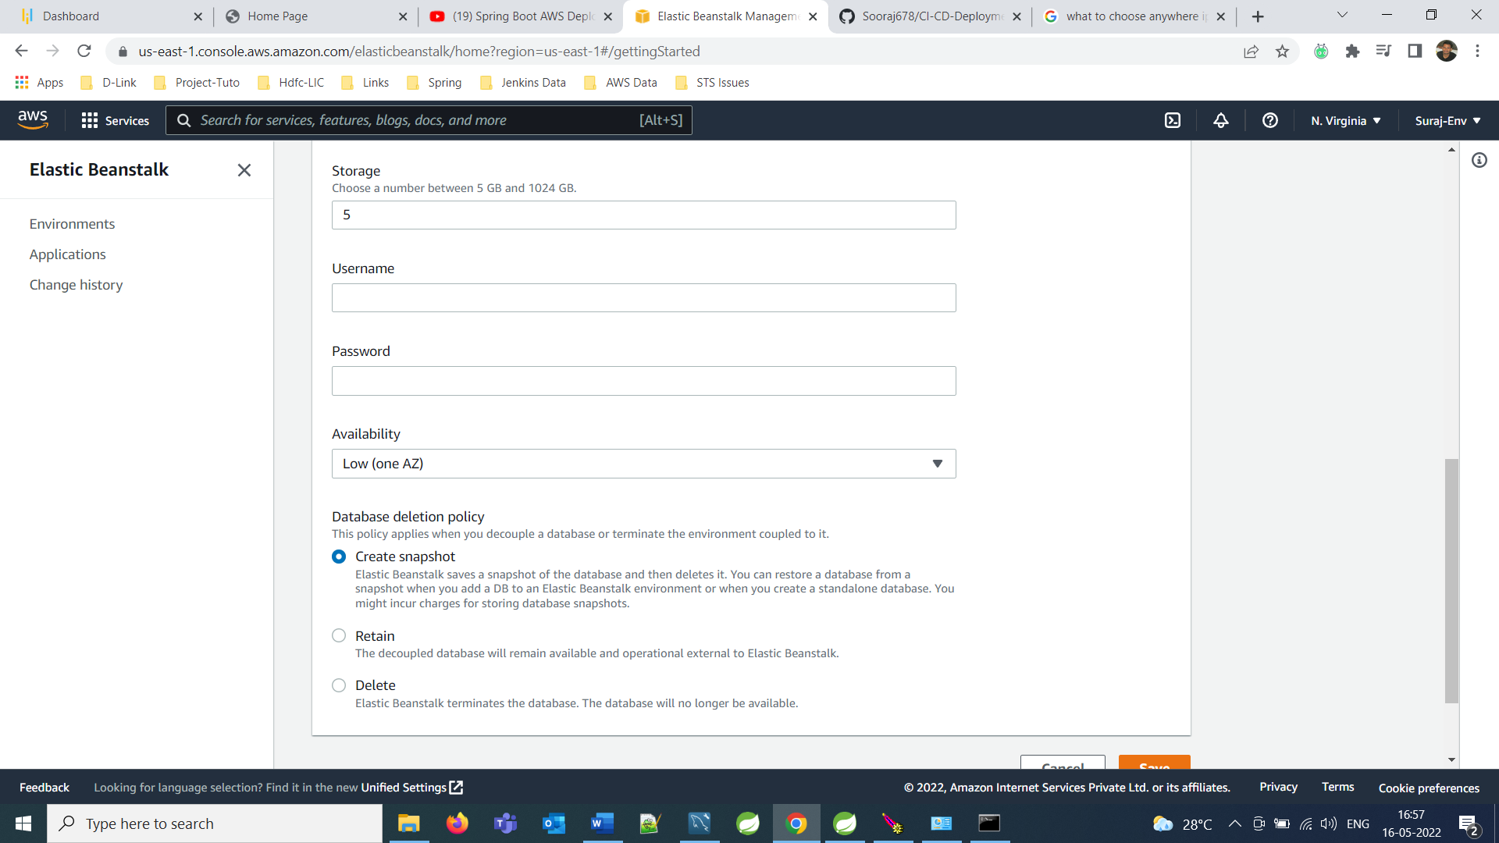

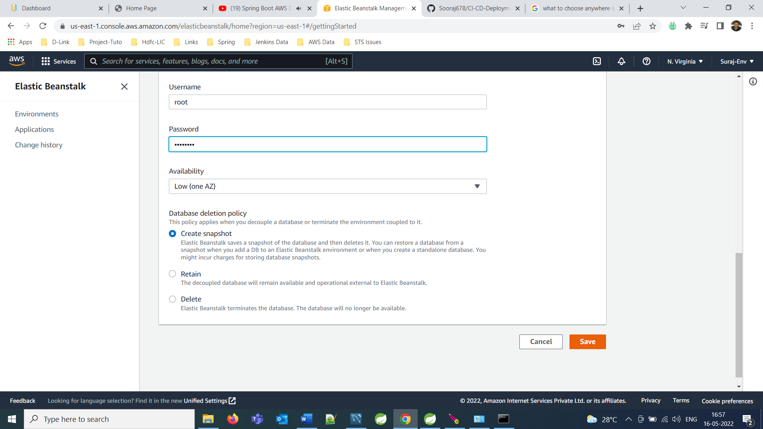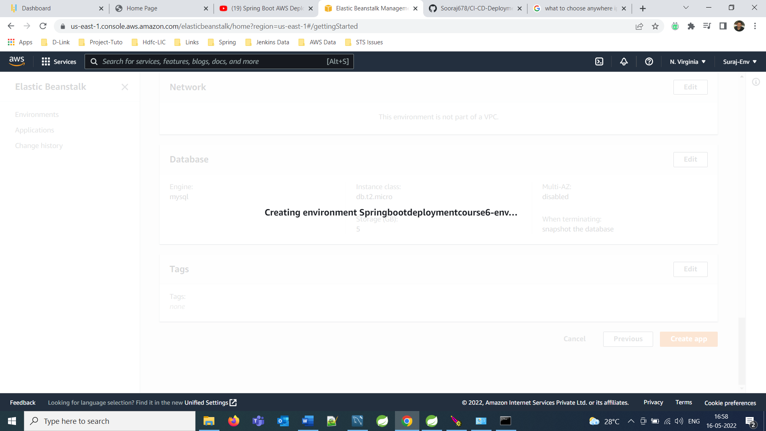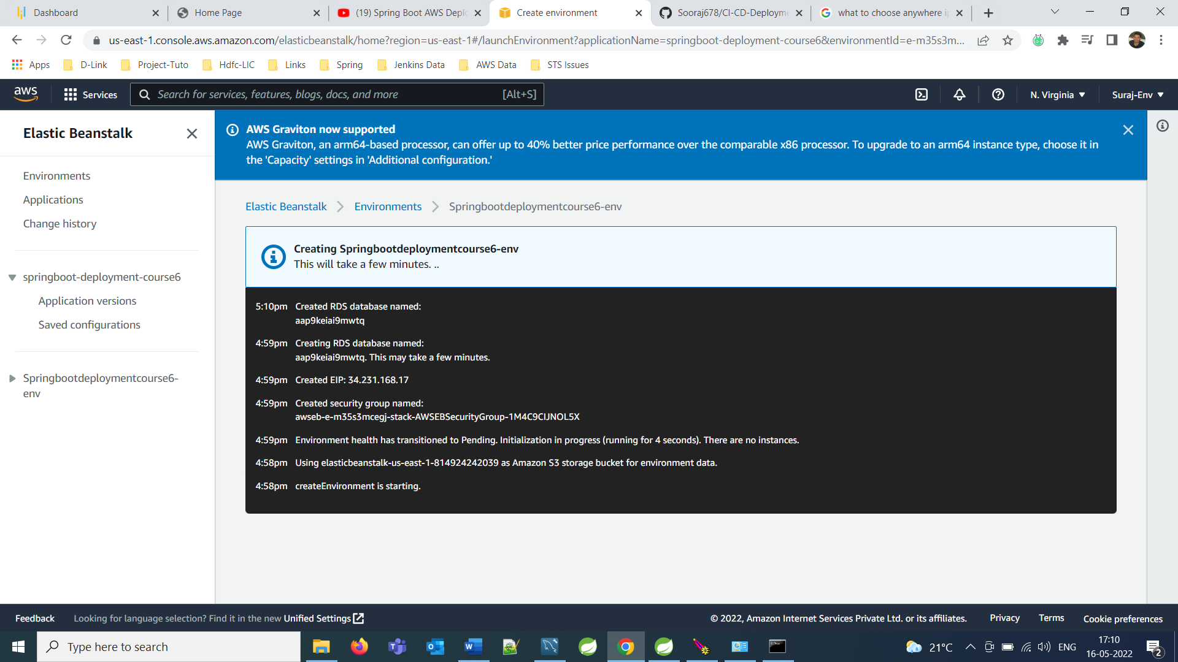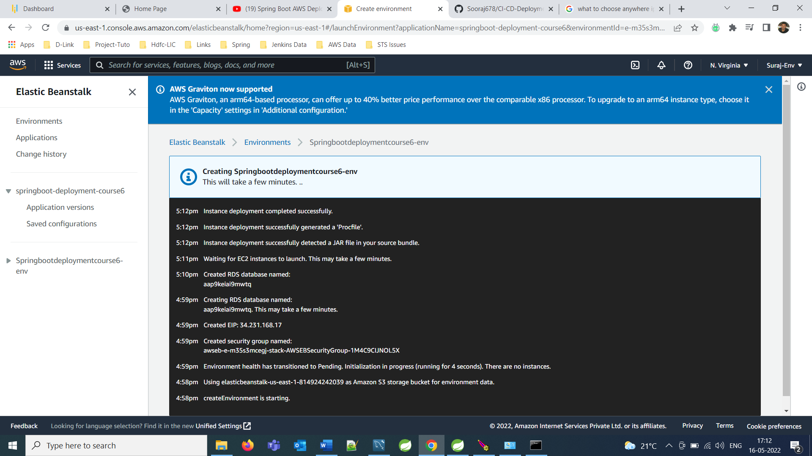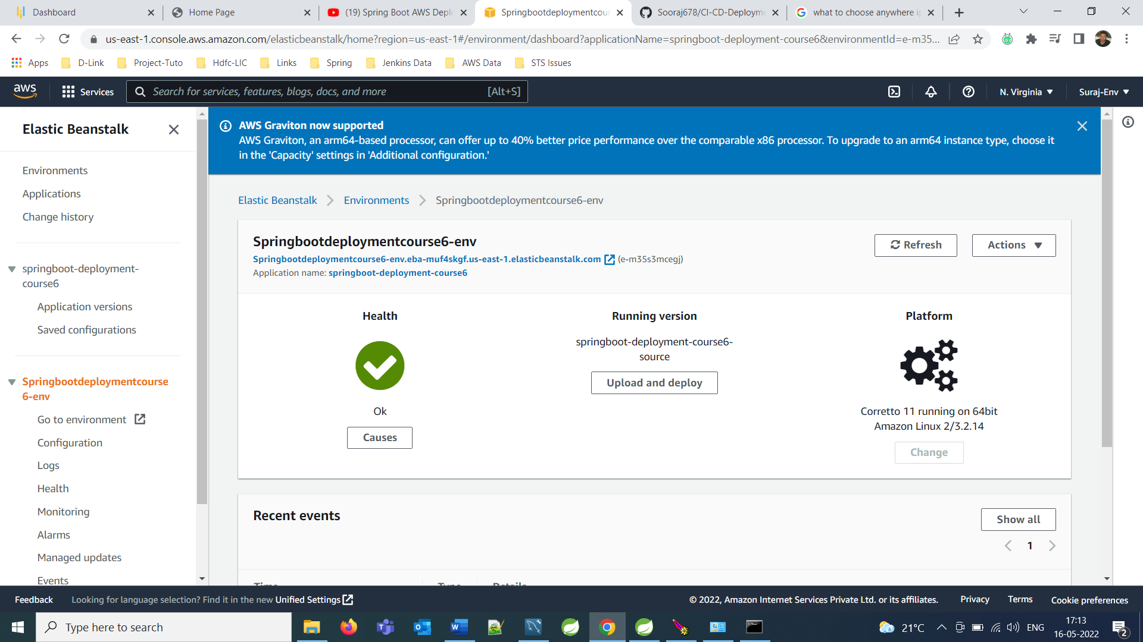

**Solution Overview of Employee Management Pvt. Ltd. && Its Components and Interfaces in System.**

**--------------------------------------------------------------------------**

**Project Requirement**

This is the Web Application for Employee Management System: And User should be able to:

* Get All the Employees
* Add a new Employee
* Update an Employee
* Delete an Employee

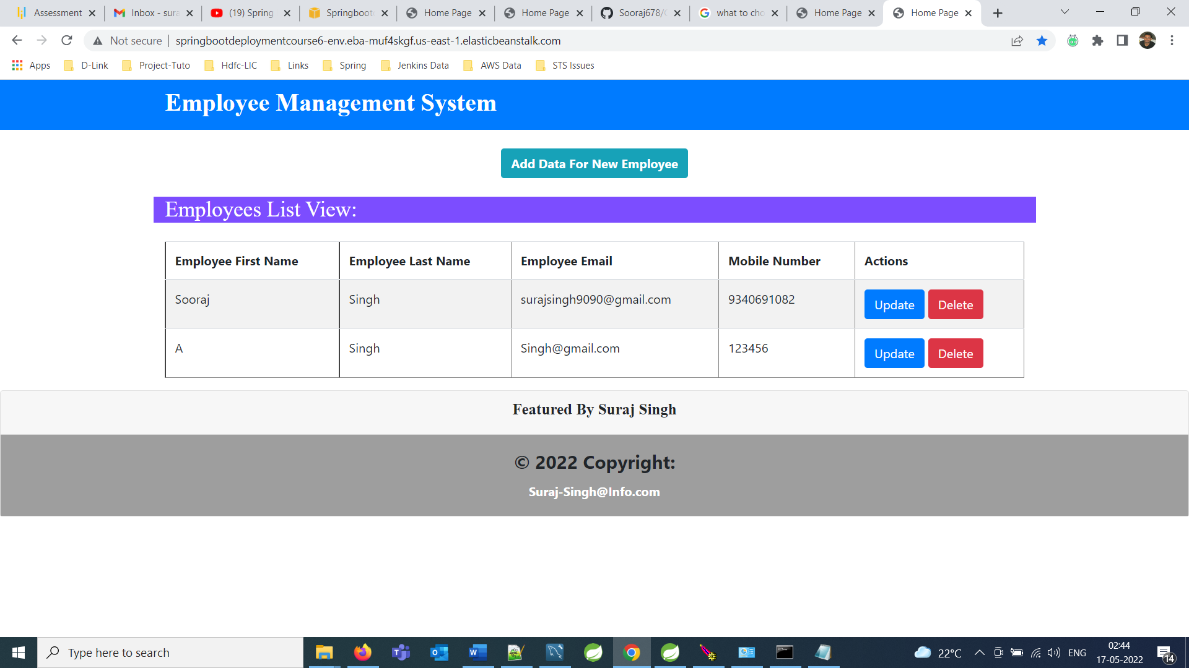

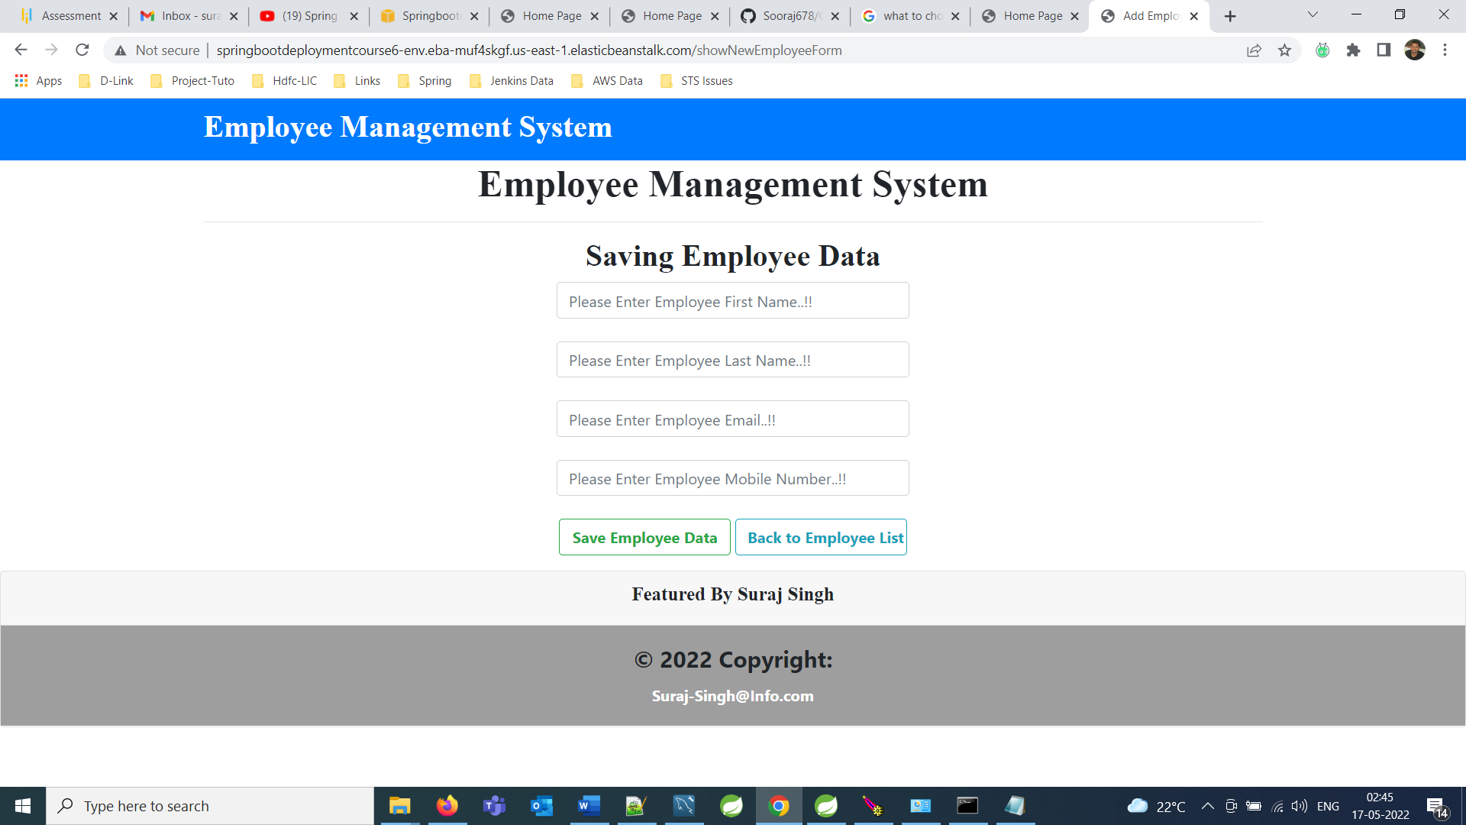 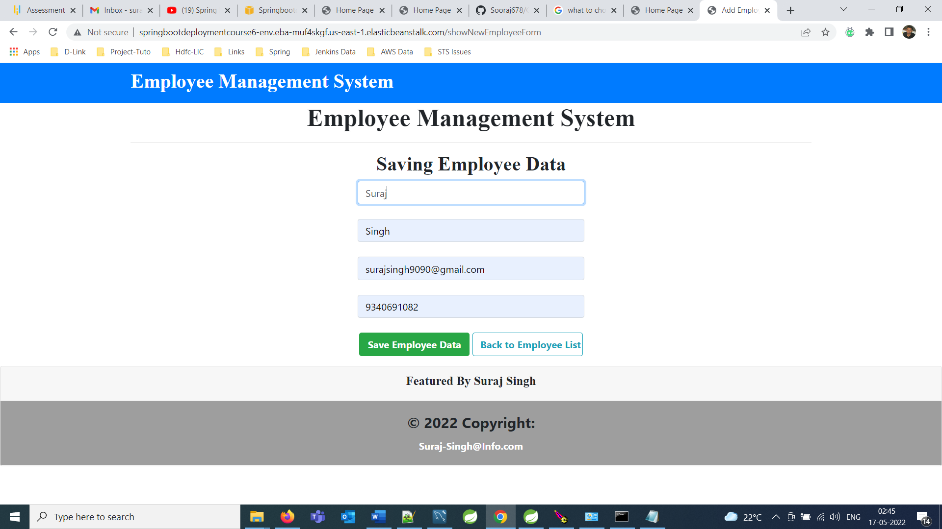 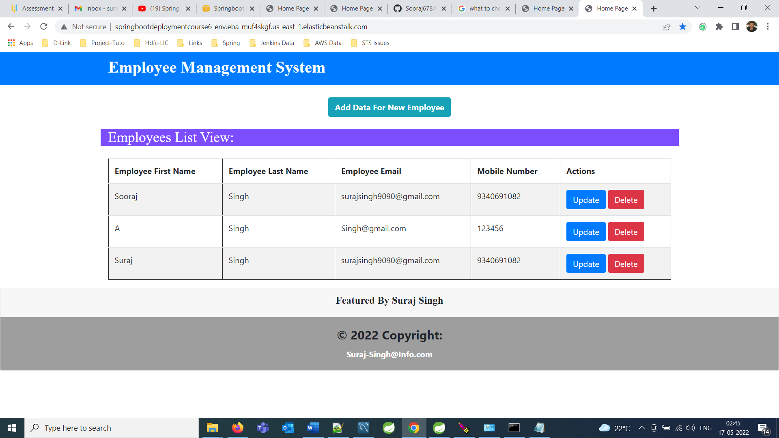 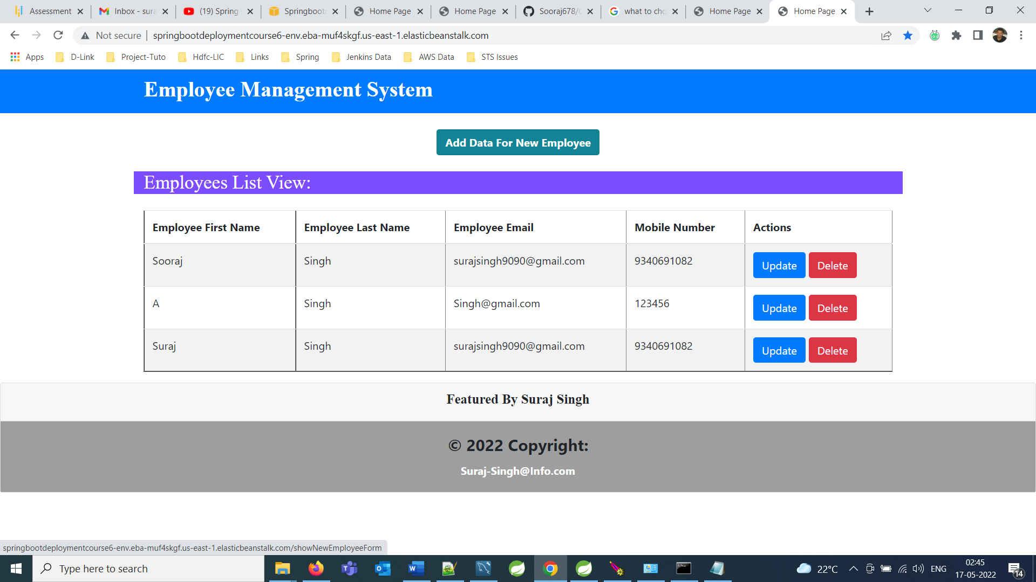 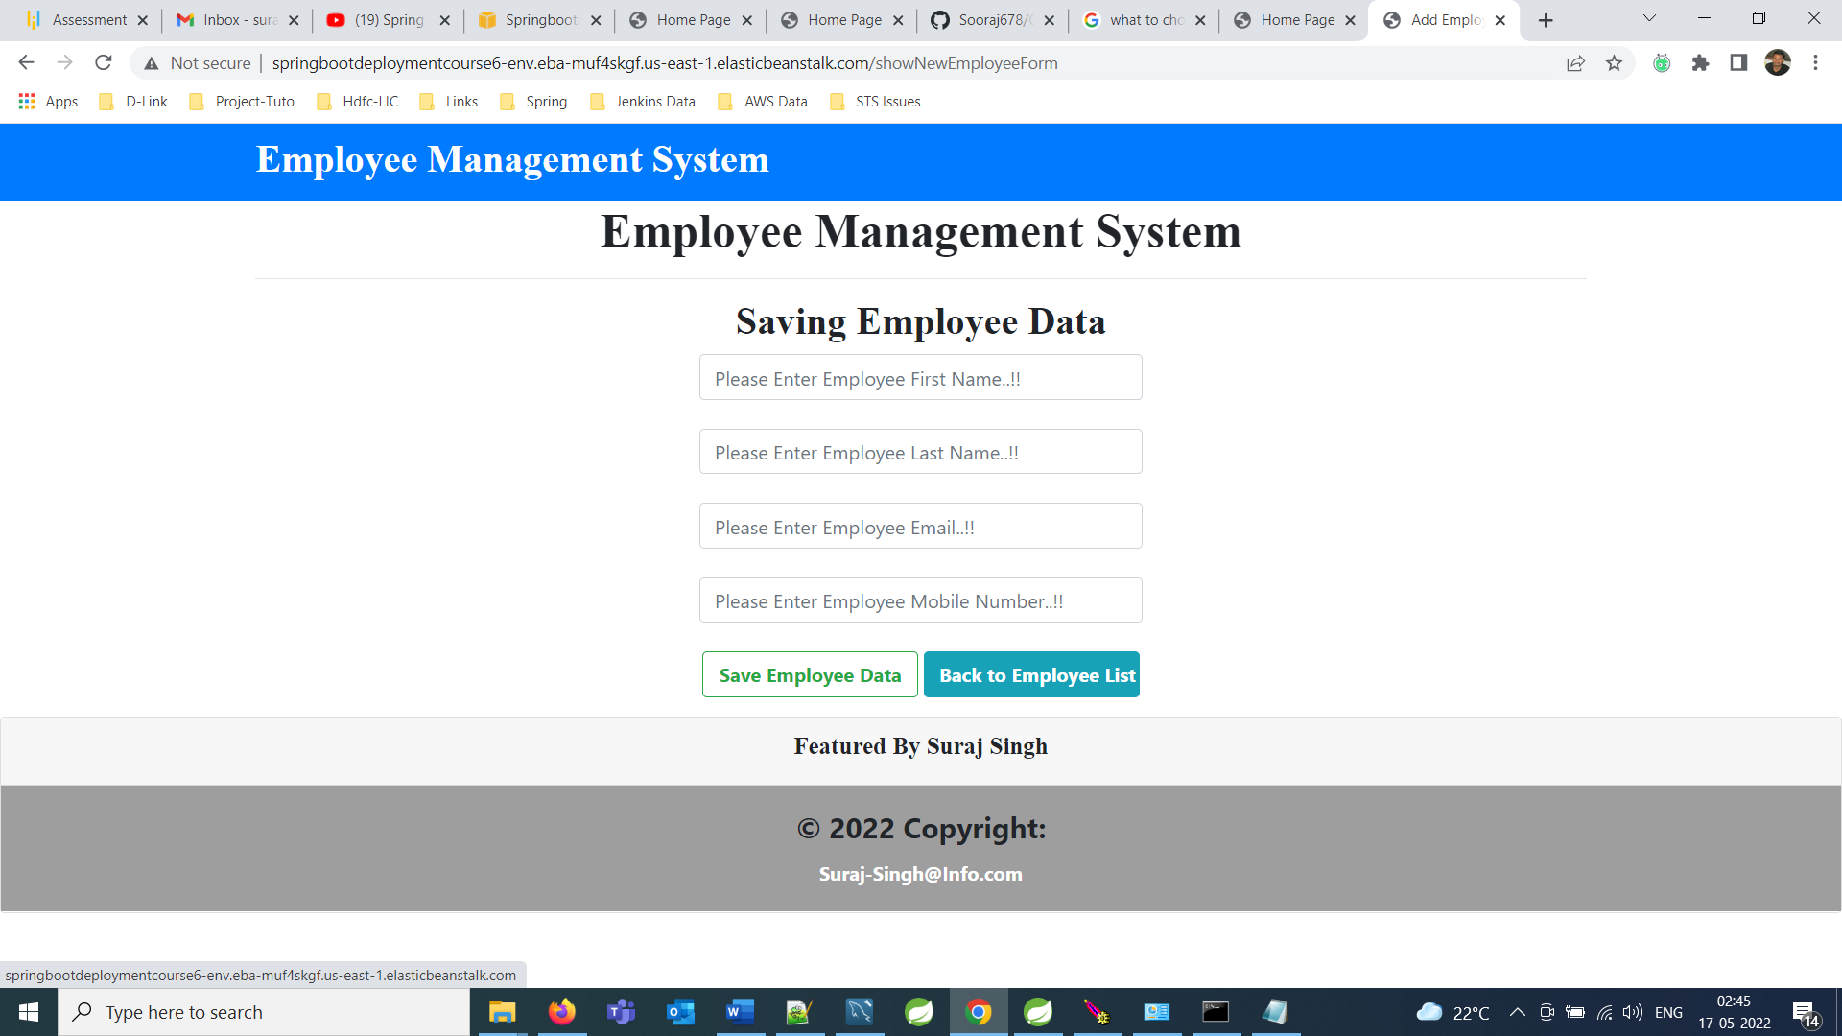

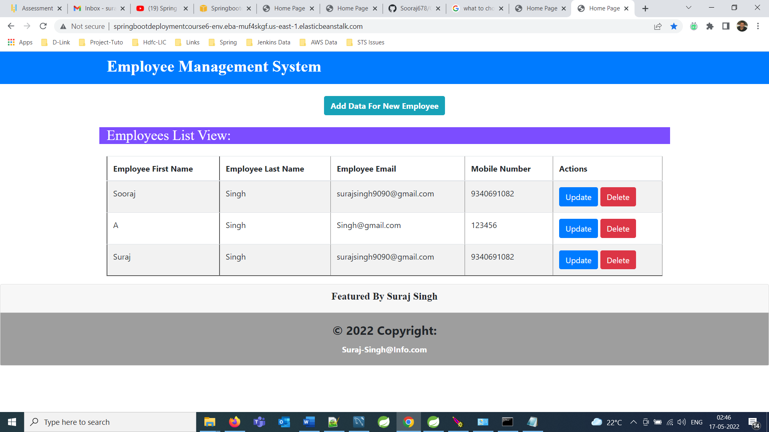

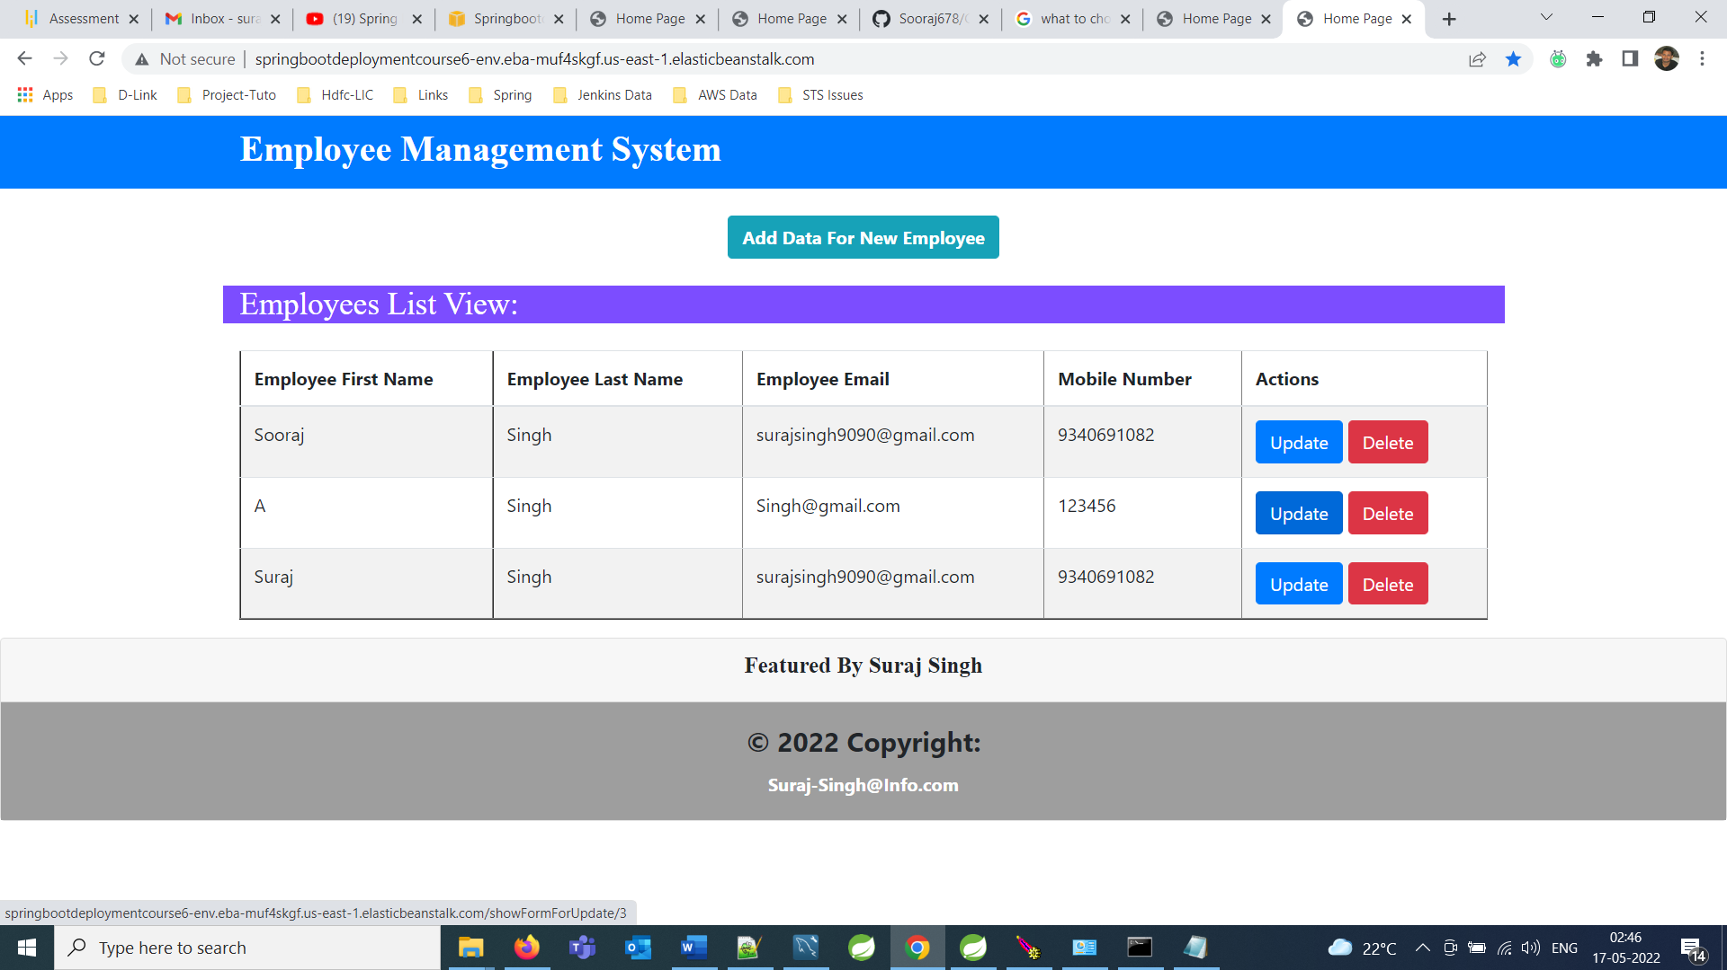 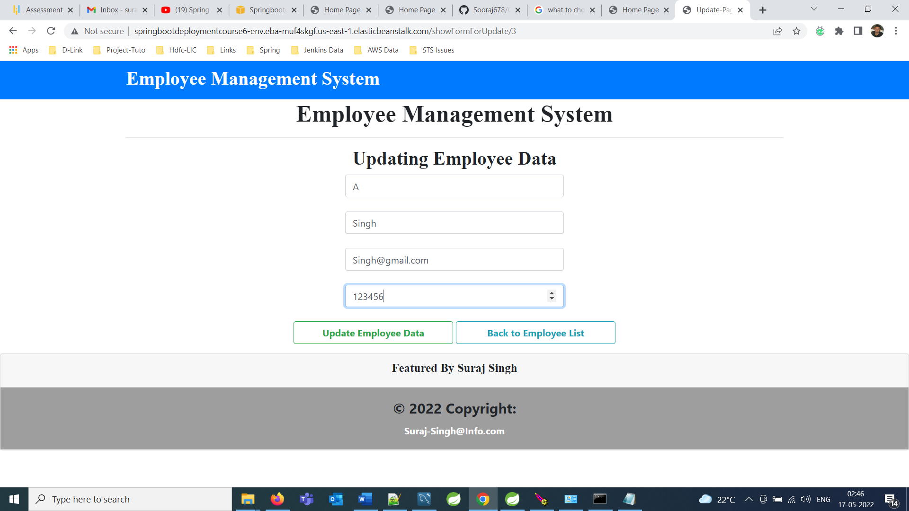

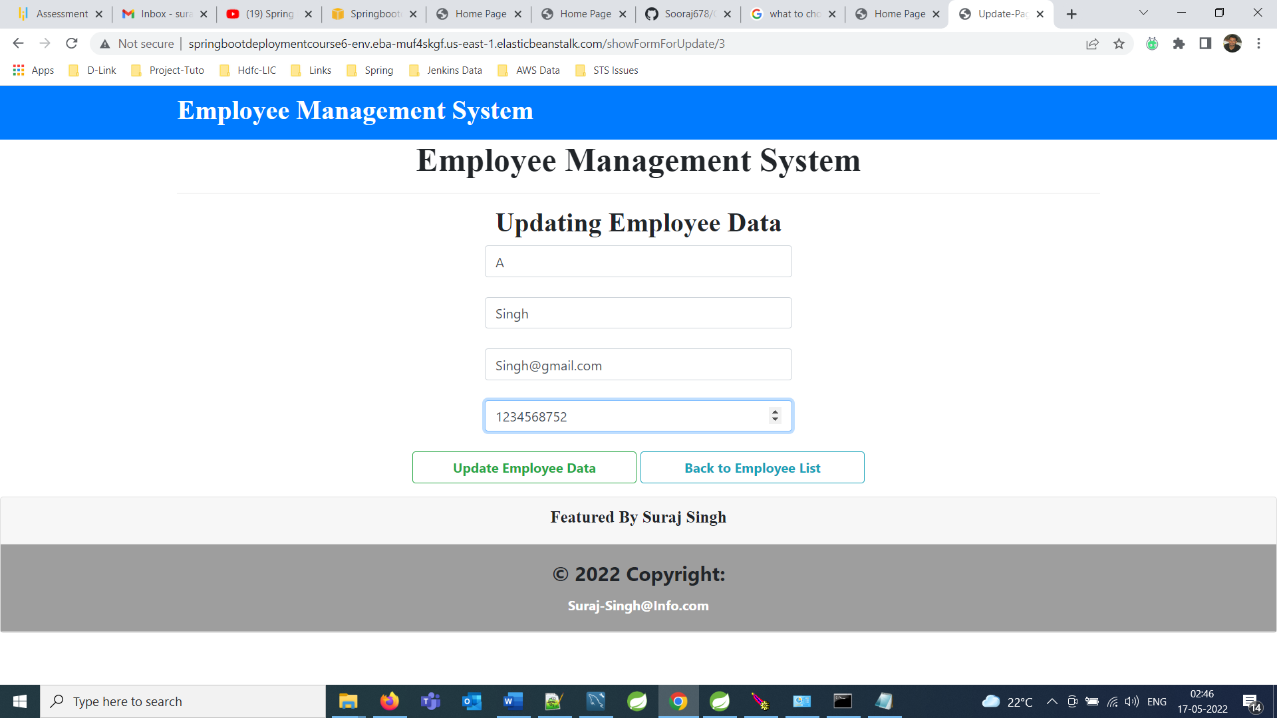 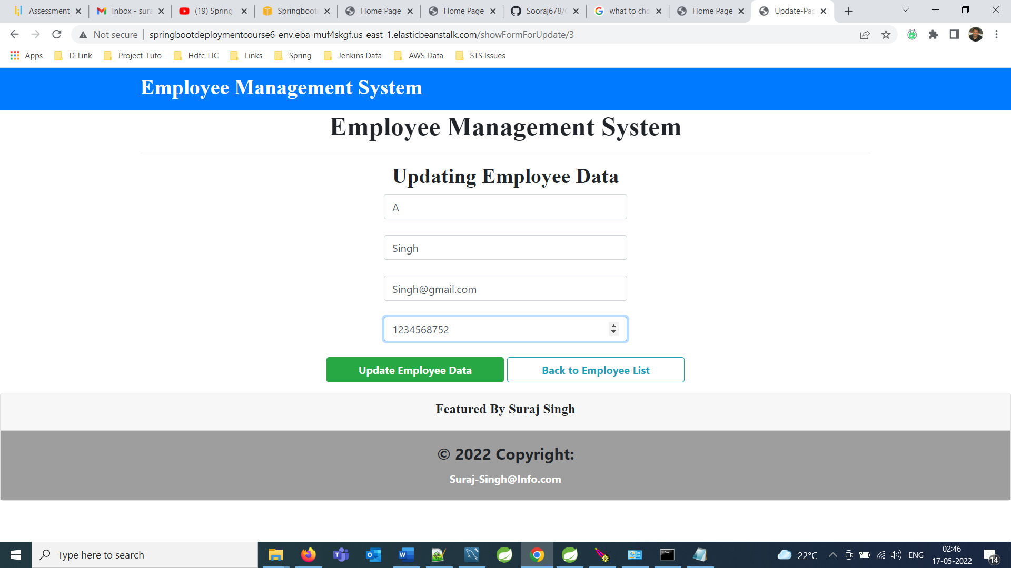 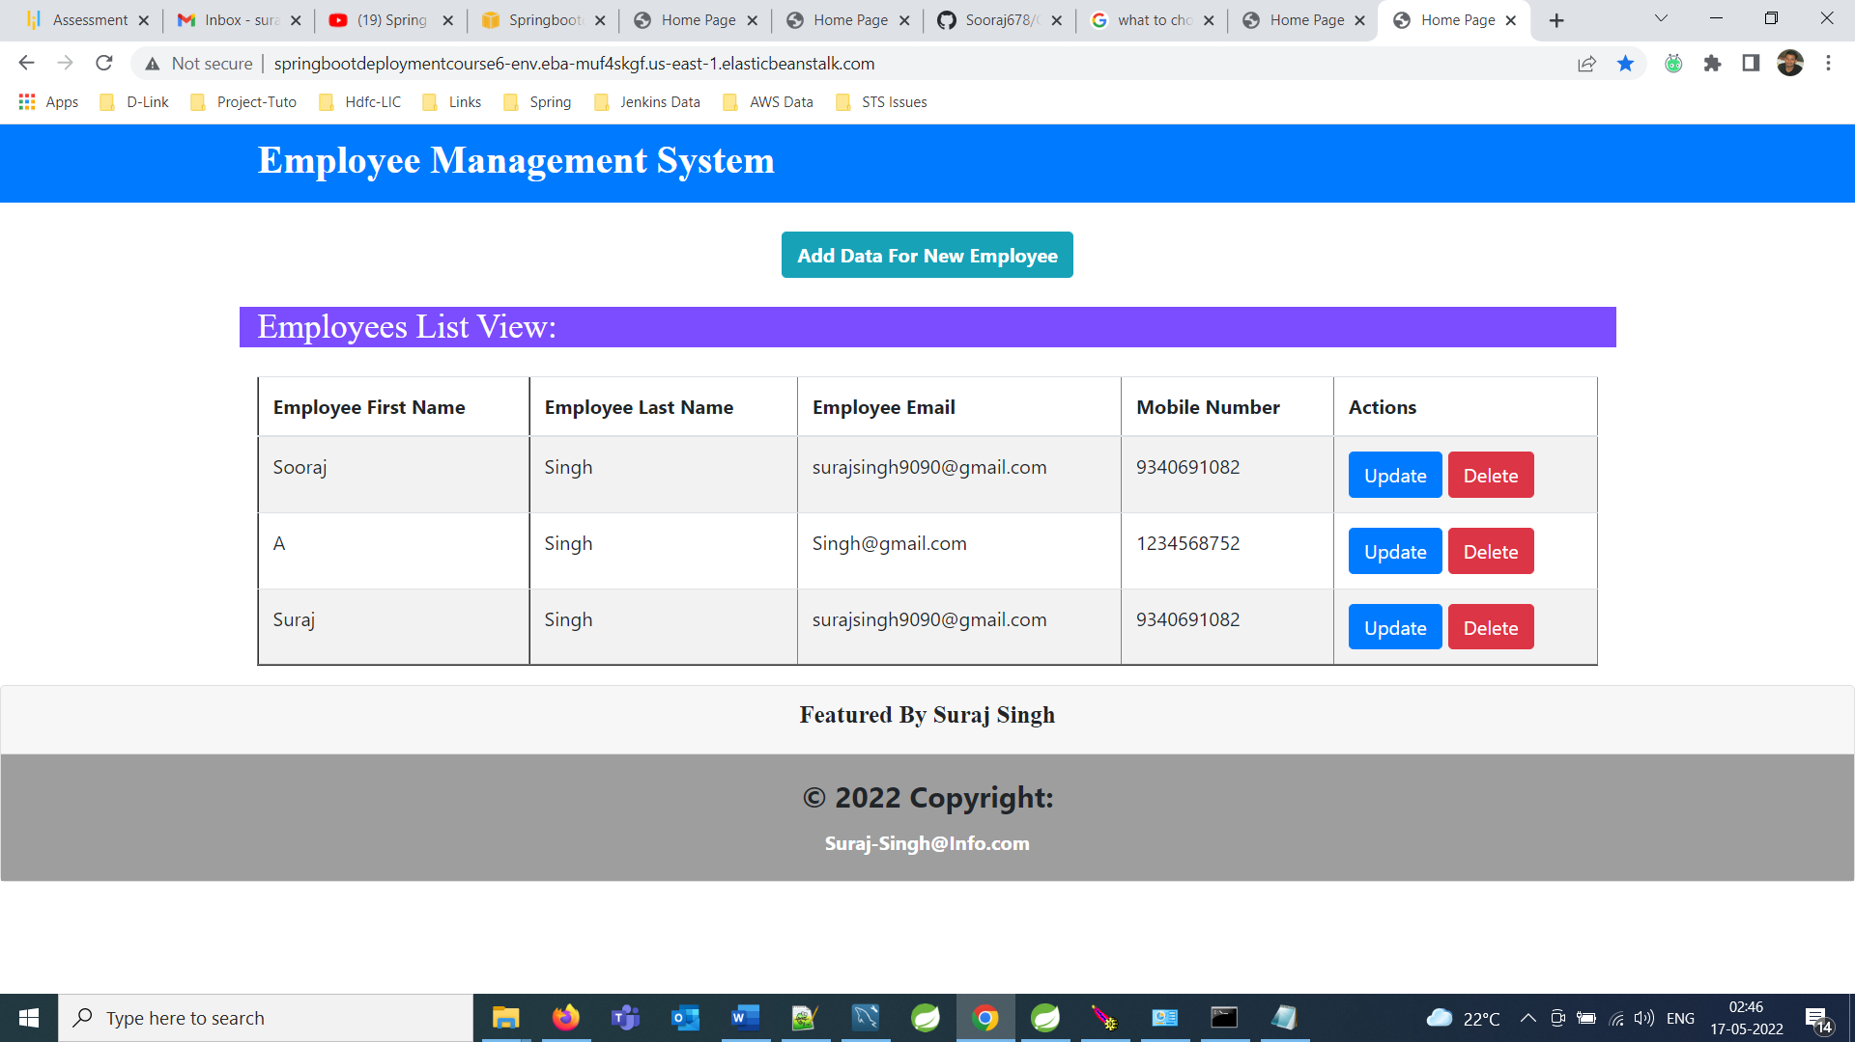

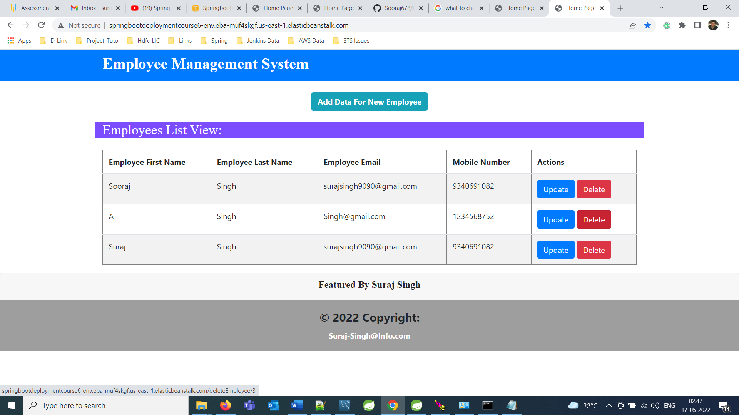

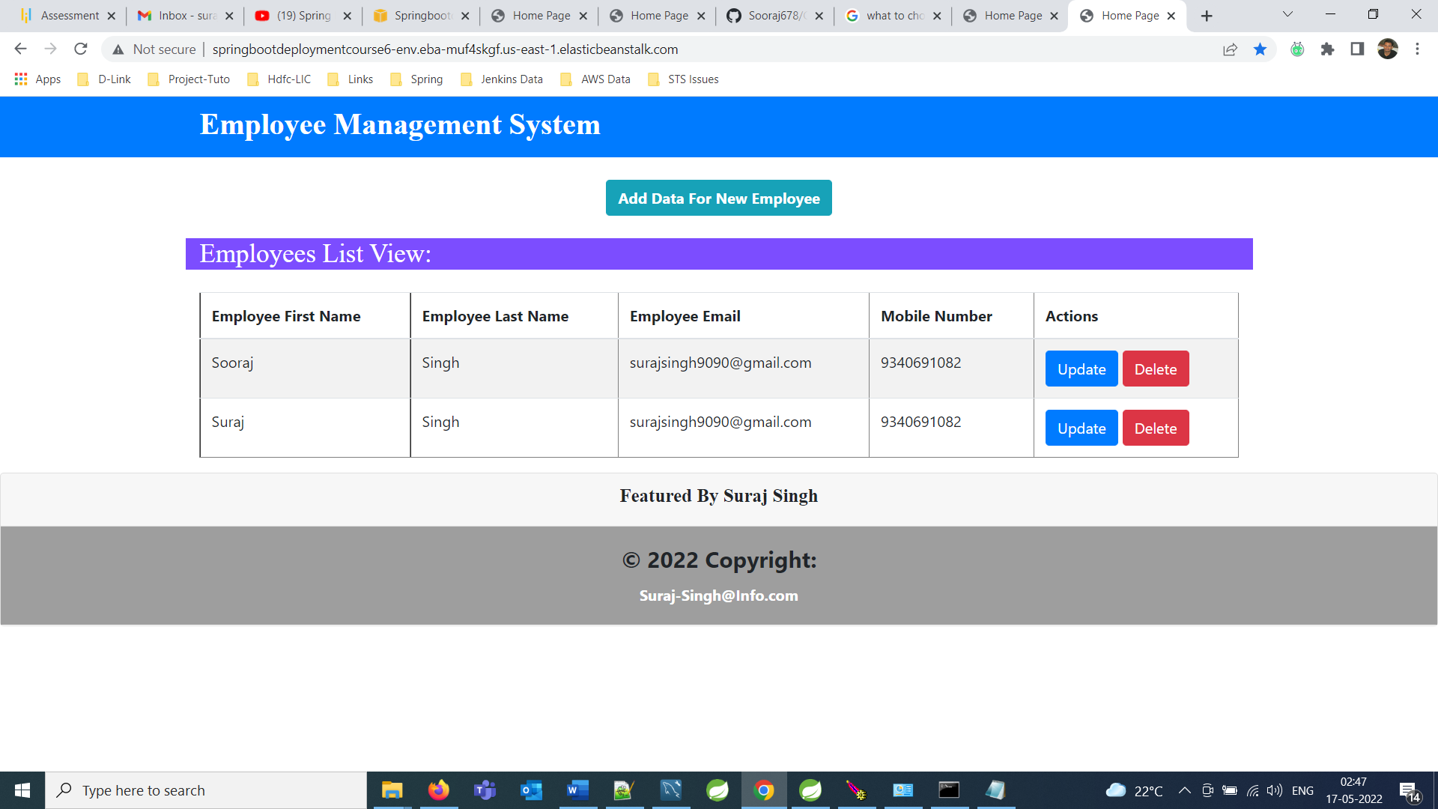

***DataBase Details***

Provides the information about Database.

This Application contains only one table that is

Employees in which id is Primary Key and Autogenerated.

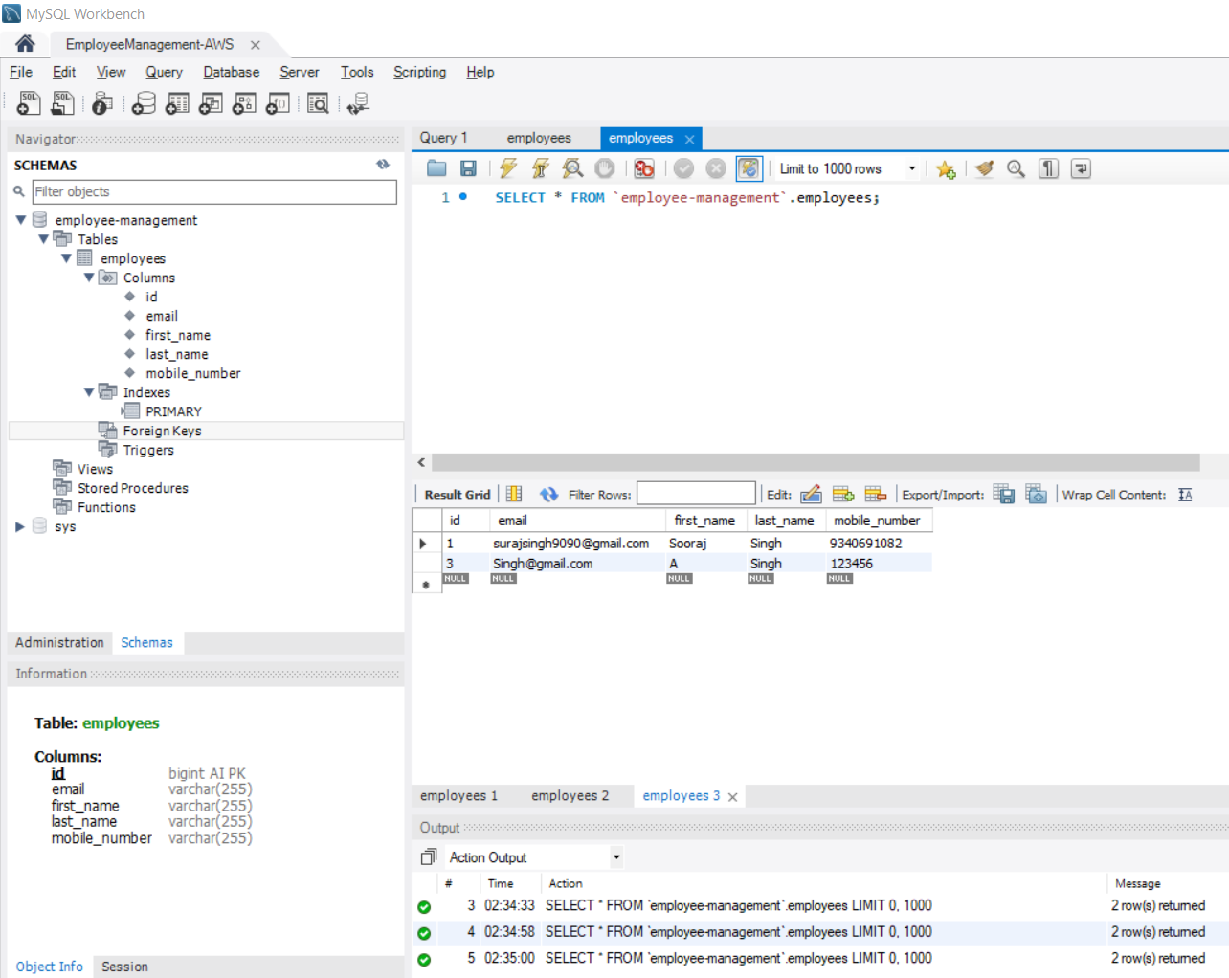

***Link of Project after Deployment of Project***

Provides the information about link of Project.

[*http://springbootdeploymentcourse6-env.eba-muf4skgf.us-east-1.elasticbeanstalk.com/*](http://springbootdeploymentcourse6-env.eba-muf4skgf.us-east-1.elasticbeanstalk.com/)

***GitHub Link***

Provides the information where the project is located.

[*https://github.com/Sooraj678/CI-CD-Deployment-for-Springboot-WebApp*](https://github.com/Sooraj678/CI-CD-Deployment-for-Springboot-WebApp)